GOVERNMENT FIRE SERVICES

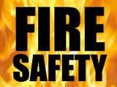 AT HOME

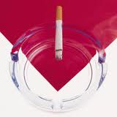
SMOKING

- Do not leave a lit cigarette, cigar or pipe unattended. They can easily fall or be knocked onto a carpet or papers and start a fire.

- Avoid smoking you are tired, taking medication, or if you’re under the influence of alcohol or drugs. It’s too easy to fall asleep and not notice that a cigarette is still burning.

- Do not smoke in bed.

- Make sure you have completely extinguished smoking materials before leaving the house or going to bed.

- Keep smoking materials out of reach of children.

- Use a proper ashtray. Make sure the ashtray cannot be easily knocked over and empty frequently.

- Empty cold ash into a metal container and preferably outside.

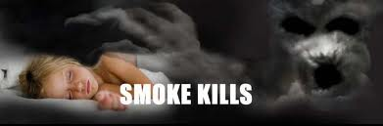
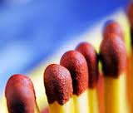

MATCHES AND LIGHTERS

- Matches and lighters should be stored out of sight and out of reach of children (well above the normal level of reach of your children).

- Never underestimate a child's ability to use matches or lighters. Very young children are able to strike a match or use a lighter simply by watching others around them. However, they are not able to control them and do not understand the possible consequences.

- A child's natural reaction to danger or trouble is to run away and hide - they are very unlikely to come and tell you what they have just done! Children will hide under beds or in cupboards to avoid the fire, which could lead to fatal results for them and for you.

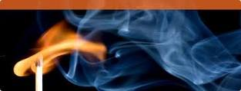

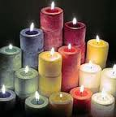

CANDLES

- Keep candles away from anything that can easily catch fire like curtains, shelving, fabrics and other furnishings.

- You need to keep candles firmly upright in a proper holder.

- Always place candles on a heat resistant surface. Candles can melt plastic surfaces like the tops of televisions and bathtubs.

- Don’t lean across candles! You could set fire to your clothes or hair.

- Keep candles out of reach of children and away from pets.

- Don’t let anything fall into the hot wax.

- Never leave a burning candle unattended and ensure that candles have been completely put out when you leave the room.

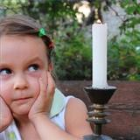

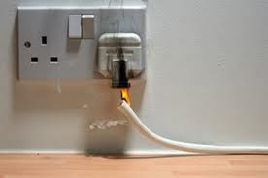

ELECTRICAL WIRING AND APPLIANCES

- Hot plugs and sockets, fuses that blow for no reason, flickering lights, and scorch marks on sockets or plugs are signs of danger.
- Check electrical leads and plugs for wear and tear and faulty wiring.

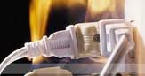

- Do not overload sockets – use one plug in each socket. If you have to use a fused adapter make sure you keep the output to no more than 13 amps.
- Keep electrical appliances clean and in good working order, and have them serviced regularly.
- Switch off and unplug electrical appliances if you are not using them, unless they are designed to be left on.

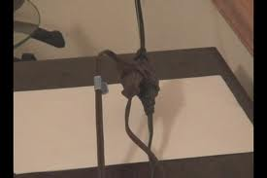
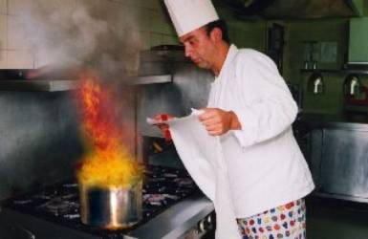

COOKING AND DEEP FRYING

- Pay attention to your cooking. Stay in the kitchen when you are cooking.

- If you must leave the kitchen, even for a short period of time, turn off your stove. .

- Never fill your cooking pan more than one third full of oil.

- If you deep-fry food, dry it before you put it in the hot oil. If the oil starts to smoke, turn off the heat and leave the pan to cool.

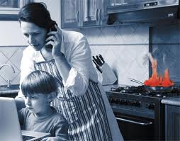

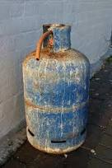

LPG

- After use, turn off the cylinder valve while the appliance is still operating. Then turn off the appliance valve. This allows the hose to empty of gas.

- Check rubber hose regularly for cracks and change hose before expiry date.

- Strike the match first then open the burner knob of your stove.

- Always keep the cylinder in vertical position.

- In case of leakage turn off the gas valve, open all doors and windows and do not switch on/off any electrical equipment inside the house and don’t light matches and lighters.

IF YOUR CLOTHES CATCHES ON FIRE

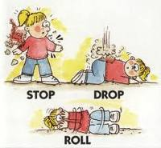

Stop, drop and roll!

- Do not run around.

- Lie down and roll on the floor.

- If someone else is on fire, tell them to lie down then smother flames with a heavy material like a coat, blanket or fire blanket.

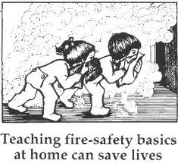

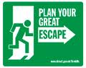

BE PREPARED BY MAKING A PLAN OF ESCAPE

- Plan an escape route and make sure everyone knows how to escape.

- Make sure exits are kept clear.

- The best route is the normal way in and out of your home.

- Think of a second route in case the first one is blocked.

- Take a few minutes to practice your escape plan.

- Review your plan if the layout of your home changes.

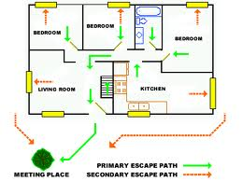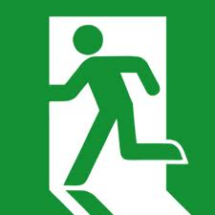

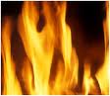

WHAT TO DO IF THERE IS A FIRE?

- Keep calm and act quickly, get everyone out as soon as possible.

- Don`t waste time investigating, what`s happened or rescuing valuables.

- If there`s smoke, keep low, where the air is clearer.

- Before you open a door check if it`s warm. If it is, don`t open it – fire is on the other side.

- Call the Fire Services on 115 as soon as you`re clear of the building.

- 115 calls are free.

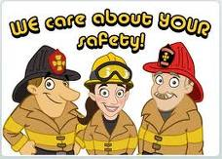
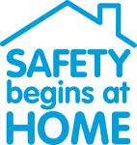

MAKE A BED TIME CHECK

CHECK LIST :-

- Close inside doors at night to stop a fire from spreading.

- Turn off and unplug electrical appliances unless they are designed to be left on- like your freezer.

- Check your cooker is turned off.

- Don`t leave the washing machine on.

- Turn heaters off and put up fireguards.

- Put candles and cigarettes out properly.

- Make sure exits are kept clear.

- Keep door and window keys where everyone can find them.

