Road Traffic (Construction and Use of Vehicles) Regulations 2010
GN No. 53 of 2010
Government Gazette of Mauritius No. 12 of 13 February 2010
THE ROAD TRAFFIC ACT
Regulations made by the Minister under sections
105 and 190 of the Road Traffic Act
1. Short title
These regulations may be cited as the Road Traffic (Construction and Use of Vehicles) Regulations 2010.
2. Interpretation
In these regulations -
"agricultural tractor" means a motor tractor intended solely for the purposes of agriculture;
"anchorage points" means points designed to hold a seat belt securely in position on the vehicle;
"articulated vehicle" means a combination of a drawing vehicle and one or more trailers;
"axle", in relation to a vehicle, means a device around which the wheels of the vehicle rotate and which is so placed that, when the vehicle is travelling straight ahead, the vertical centre-lines of the wheels are in one vertical plane at right angles to the longitudinal centre-line of the vehicle;
"axle unit", in relation to a vehicle, means a set of 2 or more parallel axles of the vehicle which are so interconnected as to form a unit;
“brake lamp” means a lamp referred to in regulation 41;
"braking efficiency" means the maximum braking force capable of being developed by the brakes of a vehicle, expressed as a percentage of its gross weight including part of the load and the maximum of the average weight of the number of persons the vehicle is allowed to carry;
"British Standard" means a standard issued by the British Standard Institution;
"bull bar" means any metal, alloy or other hard material in the nature of a crash bar, other than a bumper, fitted to the front of a vehicle, whether as part of the original design of the vehicle or not;
"centre-line of an axle unit" means a line midway between the centre-lines of the extreme axles of an axle unit;
"Class A" and "Class B", in relation to inflammable liquids, have the same meaning as in the Inflammable Liquids and Substances Regulations 1953;
"class label", in relation to a dangerous or hazardous substance, means the label specified in the third column of the First Schedule;
"consignor", in relation to a dangerous or hazardous substance intended for carriage by a goods vehicle, means the owner of the substance;
"container" means a transportation container of goods of not less than 2.4 metres by 2.4 metres by 3 metres in dimension which is designed to be carried on a goods vehicle;
"dangerous or hazardous substance" means a substance specified in the second column of the First Schedule;
"db(A)" means the A-weighted sound pressure level expressed in decibels;
"deck", in relation to a bus, means a floor or platform on which seats are provided for the accommodation of passengers;
"direction indicator" means a lamp fitted to a motor vehicle used to indicate to road users that the driver intends to turn right or left;
"emergency brake" means a brake, additional to a service brake, provided to stop a vehicle in case of failure of the service brake;
"emergency information panel" means the panel specified in the Second Schedule;
“engineering equipment” -
(a) means equipment designed for the purpose of engineering operations; and
(b) includes a vehicle or crane which constitutes engineering plant;
“engineering plant” means -
(a) a motor vehicle or trailer specially designed for the purpose of engineering operations which, independently of these regulations, is not constructed primarily to carry a load other than excavated materials raised from the ground by an apparatus on the motor vehicle or trailer or materials which the vehicle or trailer is specially designed to treat while being carried on it; or
(b) a mobile crane designed for the purpose of engineering operations;
“fog lamp” means a lamp referred to in regulation 38;
“front end”, in relation to a vehicle, means that part of the vehicle which projects furthest forward;
"front fog lamp" means a fog lamp fitted to the front of a motor vehicle;
"fuel tank" means a tank fitted to a motor vehicle and intended for the storage of fuel for the propulsion of the vehicle;
“gangway”, in relation to a vehicle -
(a) means the space allowing user access from any entrance to the passengers' seats or from any seat to an exit other than an emergency exit; but
(b) does not include a staircase or any space in front of a seat or row of seats;
"gross combination weight" means the maximum allowable combined weight of a fully loaded drawing motor vehicle and any combination of attached trailers specified by the manufacturer or otherwise determined by the Commissioner where the manufacturer has not specified the maximum combination weight;
"hazard warning device" means a device which is capable of causing all the direction indicators with which a vehicle is fitted to operate simultaneously;
"head lamp" means a lamp, other than a fog lamp, used to illuminate the road in front of a motor vehicle;
"horn" means an instrument, other than a bell, gong or siren, capable of giving audible and sufficient warning of the approach or position of a vehicle to which it is fitted;
"hours of darkness" means the time between half an hour after sunset and half an hour before sunrise;
"indivisible load" means a load which cannot, without undue expense or risk of damage, be divided into 2 or more loads for the purpose of conveyance on a road;
"inflammable liquid" has the same meaning as in the Inflammable Liquids and Substances Regulations 1953;
"light goods vehicle" means a goods vehicle having a gross weight not exceeding 3,500 kilograms;
“liquefied petroleum gas” means -
(a) butane gas in any phase which meets the requirements contained in the specification of commercial butane and propane issued by the British Standards Institution under the number BS 4250: 1975.
(b) propane gas in any phase which meets the requirements contained in that specification; or
(c) a mixture of such butane gas and such propane gas;
"matched pair", in relation to reflectors, direction indicators, lamps or rear markings, means a pair which -
(a) emits light of substantially the same colour and intensity; and
(b) is of the same size and of such shape that it is symmetrical to each other;
“microbus” means a bus which -
(a) is designed to carry not more than 16 persons including the driver;
(b) has a gross weight not exceeding 3,500 kilograms; and
(c) is not designed for the carriage of standing passengers;
"minibus" means a bus which is designed to carry more than 16 but not more than 32 persons including the driver;
"multi-tone horn" means an instrument which can automatically produce -
(a) a sound which alternates at regular intervals between 2 fixed notes;
(b) a tune made of 2 or more notes;
"nearside" means the side of a vehicle nearest to the road edge when it is parked on the left side of the road;
"offside" means the side of a vehicle furthest from the road edge when it is parked on the left side of the road;
"omnibus" means a bus which is designed to carry more than 32 persons;
"overall height", in relation to a vehicle, means the distance measured from ground level to the point of the vehicle which is furthest from the ground, when -
(a) the tyres of the vehicle are suitably inflated for the use to which it is being put; and
(b) the surface of the ground under the vehicle is reasonably flat;
"overall length", in relation to a vehicle, means the distance between its front and rear ends and, in relation to a combination of vehicles, the distance between the front end of the leading vehicle and the rear end of the rearmost vehicle inclusive of all parts of the vehicle, of any receptacle of a permanent character and any fitting on, or attached to, it except -
(a) a driving mirror;
(b) an extensible contrivance forming part of a turntable fire escape fixed to the vehicle;
(c) a tailboard which is let down while the vehicle is stationary in order to facilitate its loading or unloading;
(d) sheeting or other readily flexible means of covering or securing loads;
(e) an empty receptacle which itself forms a load;
(f) a receptacle which contains an indivisible load of exceptional length;
(g) an apparatus, such as a crane, which is a permanent fixture but which does not itself increase the carrying capacity of the vehicle; or
(h) in the case of a trailer, the part which is designed to be coupled to another vehicle;
"overall width", in relation to a vehicle, means the distance between longitudinal planes passing through the extreme lateral projecting points of the vehicle, inclusive of all parts of the vehicle, of any receptacle which is of a permanent character and any fitting on, or attached to, it except -
(a) a driving mirror;
(b) a reflector fitted to the vehicle;
(c) a sideboard which is let down while the vehicle is stationary in order to facilitate its loading or unloading;
(d) sheeting or other readily flexible means of covering or securing a load;
(e) a receptacle which contains an indivisible load of exceptional width;
(f) an empty receptacle which itself forms a load; or
(g) an apparatus, such as a crane, which is a permanent fixture but which does not itself increase the carrying capacity of the vehicle;
"overhang" means the distance by which the body and other parts of a vehicle extend beyond its front or rear axle;
"overrun brake", in relation to a trailer, means a braking device fitted to its drawbar which makes use of the force of inertia to prevent the vehicle from moving;
"pair", in relation to direction indicators, lamps, reflectors or rear markings, means a pair, including a matched pair, one on each side of the vehicle, where -
(a) each direction indicator, lamp, reflector or rear marking is at the same height above the ground; and
(b) each direction indicator, lamp, reflector or rear marking is at the same distance from the outer edge of the vehicle;
"parking brake" means a handbrake or other brake normally used to keep a vehicle stationary;
“pedal cycle” -
(a) means a vehicle which is not designed to be propelled by mechanical power and which is equipped with pedals; and
(b) includes an electrically-assisted pedal cycle;
"petroleum tanker" means a vehicle designed to carry inflammable liquids for distribution principally or solely in a tank constructed as part of, or firmly secured to, the vehicle;
"pneumatic tyre" means a tyre which, where it is provided with, or together with the wheel upon which it is mounted, forms a continuous closed chamber inflated to a pressure when the tyre is in the condition in which it is normally used, but is not subjected to any load -
(a) is capable of being inflated and deflated without having to be removed from the wheel or vehicle; and
(b) is such that, when deflated and subjected to a normal load, the sides of the tyre will collapse;
"protective device" means a permanent metal frame fixed to the underside of the rear of a vehicle;
"rear end", in relation to a vehicle, means that part which projects furthest to the rear;
"rear fog lamp" means a fog lamp fitted in the rear of a vehicle;
"rear lamp" means a lamp referred to in regulation 40;
"rear marking" means a rear marking of the type shown in diagrams 1 to 5 set out in paragraph 1 of Part I of the Third Schedule;
"recovery vehicle" means a motor vehicle used for the purpose of attending to, effecting repairs to, or towing, a broken down vehicle;
"reflective material" means retro-reflective material which, under all circumstances, is capable of reflecting light towards the source of the light;
"registration mark" means the letters and figures appearing on a registration plate;
"registration plate" means a flat rectangular or square plate made of metal or other durable material on which the registration mark of a motor vehicle is displayed;
"reversing alarm" means a device fitted to a motor vehicle and capable of giving audible and sufficient warning of any reverse movement of the vehicle;
"reversing lamp" means a lamp referred to in regulation 43;
"safety glass" means transparent glass so constructed or treated that, on fracture, the possibility of flying fragments or sharp splinters is minimised;
"safety glazing" means transparent material other than glass, so constructed or treated that, when fractured, the possibility of flying fragments or sharp splinters is minimised;
"seat" includes any part of a vehicle designed for the accommodation of a person or a continuous seat designed for the accommodation of one or more than one person;
"seat belt" means a belt designed to prevent restraint for the upper and lower parts of the trunk of the wearer in order to prevent or lessen injury to the wearer in the event of an accident;
“semi-trailer" means a trailer so designed to form part of an articulated vehicle that part of the trailer is superimposed on the drawing vehicle;
"service brake" means a footbrake or other brake normally used to reduce the speed of a vehicle or to stop the vehicle, and which consists of –
(a) a single braking system capable of braking -
(i) the front and rear wheels of the vehicle simultaneously;
(ii) in the case of a semi-trailer, all the wheels simultaneously; or
(iii) in the case of a trailer, the front or rear wheels or all wheels simultaneously; or
(b) a dual-braking system which -
(i) jointly brakes the front and rear wheels of the vehicle simultaneously; or
(ii) independently brakes at least half the number of wheels of the vehicle simultaneously;
"side marking" means a side marking of the type shown in the diagram set out in paragraph 2 of Part I of the Third Schedule;
"side-stand" means a device fitted to a motorcycle which, when fully extended or pivoted to its open position, supports the vehicle from one side only while both wheels of the motorcycle are on the ground;
"single-decked vehicle" means a vehicle on which no part of a deck or gangway is vertically above another deck or gangway;
"skip" means equipment designed to be carried on a vehicle and be placed on a road or other surface for the storage of materials, or for the removal and disposal of rubble, waste, earth, household or other rubbish;
"special warning lamp" means a lamp fitted to the front or rear of a vehicle capable of emitting a blue and red flashing light;
"speed limiter" means a device referred to in regulation 22;
"spot lamp" means a lamp which is capable of projecting a beam of light on an object and which can be adjusted to enable the light to be deflected in any direction;
"stop lamp" means a lamp used to indicate to other road users that the brakes of a vehicle or combination of vehicles are being applied;
"tandem axle" means an assembly of 2 axles mounted at a certain distance apart which may be driven at the same time;
"tank" means a metal tank of adequate strength used for the storage of inflammable liquids;
"track laying vehicle" means a vehicle designed so that its weight is transmitted to the road surface by means of continuous tracks or by a combination of wheels and continuous tracks in such circumstances that the weight transmitted to the road surface by the tracks is not less than half the weight of the vehicle;
"triaxle" means an assembly of 3 axles mounted at a certain distance apart which may be driven at the same time;
"type approval" means a certification system by which a series of vehicles may be constructed according to a single design that may be approved in advance by the Commissioner;
"use" includes cause to be used or permit to be used;
"warning beacon lamp" means a lamp which is capable of emitting a flashing or rotating beam of light throughout 360⁰ in a horizontal plane;
"wheel", in the case of a motor vehicle or trailer, means a wheel, the tyre or rim of which is in contact with the ground when the vehicle is in motion on a road;
“wheel base” means, in the case of -
(a) a vehicle with 2 axles, the distance measured horizontally and parallel to the longitudinal axis of the vehicle between the centre points of the front axle and rear axle;
(b) a vehicle having 3 or more axles, and the front axle is only the steering axle, the distance measured horizontally and parallel to the longitudinal axis of the vehicle between the centre of the front axle and the centre point of the combination of rear axles;
"wheeled vehicle" means a vehicle so designed that the whole weight of the vehicle is transmitted to the road surface by means of wheels.
3. Application of regulations
(1) These regulations shall be in addition to and not in derogation from the Road Traffic (Control of Vehicle Emissions) Regulations 2002.
(2) Part II of these regulations shall -
(a) in the case of a bus, apply subject to Part I of the Fourth Schedule;
(b) in the case of a goods vehicle, apply subject to Part II of the Fourth Schedule.
(3) The Commissioner may, on good cause shown, exempt a vehicle or a type of vehicle from the requirements specified in section 5(3)(b)(ii) of the Act in relation to the registration of a motor vehicle or trailer in such manner and subject to such conditions as he thinks fit, including a condition as to the duration of the exemption.
PART II - DESIGN, CONSTRUCTION AND EQUIPMENT OF VEHICLES
Sub-Part A - Construction and Dimensions
4. Construction
(1) Every vehicle, including its bodywork, upholstery, fittings and accessories, shall be properly constructed of suitable materials, well finished and in good and serviceable condition, and of such design that it is capable of withstanding the load and stress likely to be met in the normal operation of the vehicle.
(2) No part of a motor vehicle, or of the load on motor vehicle, shall project more than 75 millimetres beyond the external edges of the tyres of the wheels on either side.
(3) No motor vehicle shall be fitted with a bull bar.
(4) Every motorcycle and auto cycle shall be so designed that it is a wheeled vehicle.
(5) Every motor vehicle, other than a motorcycle or an auto cycle, and every trailer shall be so designed that it is a wheeled vehicle or a track laying vehicle.
5. Chassis of motor vehicle
(1) Every motor vehicle shall be constructed on the chassis originally provided by the manufacturer which may not be extended.
(2) No motor vehicle shall be -

(a) fitted with a replacement chassis, or any replacement of a body part where the chassis is an integral part of the vehicle; or
(b) registered or licensed where the original chassis number has been erased or otherwise tampered with.
(3) The chassis number of every goods vehicle and trailer shall be highlighted with white paint, wherever it appears.
(4) The registration mark of every trailer shall be painted in bold on the nearside and off-side of the chassis midway along the wheel-base of the trailer and shall comply with the specifications listed in Part I of the Ninth Schedule.
(5) The axles of a vehicle shall be properly secured to the chassis.
(6) The body of a vehicle shall be properly secured to the chassis unless the chassis is an integral part of the vehicle.
(7) (a) Every vehicle to be registered in Mauritius shall be fitted with a chassis which is suitably designed and intended for the carriage of -
(i) passengers, in the case of a bus; or
(ii) goods, in the case of a goods vehicle.
(b) Before any body work is fitted to the chassis -
(i) it shall be submitted, for inspection, to a mechanical engineer registered with the Council of Registered Professional Engineers; and
(ii) the person responsible for the fitting shall submit to the Commissioner, for approval, detailed drawings showing the dimensions, layout of seats, doors, windows and destination indicators, where any.
(c) An approval under subparagraph (b) -
(i) shall constitute a type approval;
(ii) may not be granted unless the design is altered or updated at the request of the Commissioner; and
(iii) may be withdrawn at any time.
6. Length
(1) The overall length of a motor vehicle, other than an articulated vehicle or a vehicle which is towing a broken down vehicle, shall not exceed 12 metres.
(2) The overall length of an articulated vehicle shall, subject to paragraph (4), not exceed 18 metres.
(3) The overall length of a trailer not forming part of an articulated vehicle shall not exceed 6.7 metres.
(4) Where a motor tractor is drawing 2 trailers, the overall length of the combination of vehicles shall not exceed 24 metres, except in the case of a vehicle to which the Fifth Schedule applies.

7. Width
The overall width of a motor vehicle shall not exceed 2.52 metres.
8. Height
(1) The overall height of a motor vehicle measured from the surface on which the vehicle rests shall not exceed -
(a) 4.3 metres, in the case of a vehicle carrying a container; and
(b) 3.8 metres, in the case of any other vehicle.
(2) (a) There shall be affixed inside a motor vehicle, to which this paragraph applies and the overall height of which exceeds 3.8 metres, a legible notice visible to the person sitting at the driver's seat, indicating the overall height of the vehicle expressed in metres.
(b) This paragraph applies to every motor vehicle which is designed to be capable of -
(i) hoisting and carrying a skip;
(ii) drawing a trailer or semi-trailer carrying -
(A) a container; or
(B) an engineering equipment;
(iii) carrying a container or engineering equipment; or
(iv) carrying engineering plant.
9. Overhang
(1) Subject to paragraph (2), the rear overhang of a motor vehicle, other than a motor tractor, shall not exceed 60 per cent of the wheel base.
(2) The rear overhang of a motor tractor shall not exceed 1.8 metres.
10. Doors
Every door and every opening panel at the front or on the side of a motor vehicle shall be fitted with a primary and a secondary security device to prevent accidental opening while the vehicle is in motion.
11. Coupling of trailers
Where a motor vehicle is designed for drawing a trailer -
(a) every part of the coupling device on both vehicles shall be in efficient working order; and
(b) the bolts securing the coupling device shall be made of high tensile steel, of the correct size and toughened for the purpose.
Sub-Part B - Brakes
12. Brakes on motorcycles or auto cycles
Every motorcycle or auto cycle shall be equipped with 2 independent braking systems -
(a) one of which shall act on the front wheel and the other shall act on the rear wheel;
(b) each of which shall have a braking efficiency at least equivalent to that specified for an emergency brake; and
(c) the combined braking efficiency of which shall be at least equivalent to that specified for a service brake when they are applied simultaneously.
13. Brakes on trailers
(1) Subject to paragraph (2), every trailer shall -
(a) where its gross weight does not exceed 750 kilograms or half the tare of the drawing vehicle, be equipped with at least a parking brake or other device for keeping it stationary;
(b) where its gross weight does not exceed 750 kilograms and exceeds half the tare of the drawing vehicle but does not exceed the tare, be equipped with a parking brake and an overrun brake or a service brake;
(c) where its gross weight exceeds 750 kilograms but does not exceed 3,500 kilograms and does not exceed the tare of the drawing vehicle, be equipped with a parking brake and an overrun brake or a service brake;
(d) where its gross weight exceeds the tare of the drawing vehicle or 3,500 kilograms, as the case may be, be equipped with a parking brake and a service brake; and
(e) where its gross weight exceeds 10,000 kilograms, be equipped with a parking brake, a service brake and an emergency brake.
(2) (a) A trailer drawn by a vehicle not designed for or capable of exceeding a speed of 40 kilometres per hour on a reasonable level road, may in lieu of a service brake be fitted with an overrun brake or a brake capable of being operated by the driver of the drawing vehicle or by any other person.
(b) Where more than one trailer is drawn by a drawing vehicle, the requirements of paragraph (a) shall apply to every trailer and the gross weight shall be deemed to be the total of the gross weight of all trailers so drawn.
(3) The service brake of a trailer shall be capable of being operated by the driver of the drawing vehicle while such trailer and the drawing vehicle are in motion.
(4) Where a service or overrun brake of a trailer is capable of being used as a parking brake, a separate parking brake needs not be fitted to the trailer.

14. Brakes on other motor vehicles
(1) Subject to paragraphs (2) and (3), every motor vehicle, other than a motorcycle or an auto cycle, and every trailer shall be equipped with a service brake, a parking brake and an emergency brake.
(2) The emergency brake and the parking brake may be one and the same brake.
(3) Where a motor vehicle is equipped with a service brake consisting of 2 braking systems, the brake shall, when the systems brake the wheels independently, be deemed to include an emergency brake which shall operate automatically in case of failure of the service brake.
15. Brakes on pedal cycles
Every pedal cycle shall be equipped with at least one braking system operating on the rear wheel that will enable the rider to reduce the speed of or stop the cycle.
16. Operation and efficiency of brakes
(1) Every part of the braking system of a motor vehicle or trailer shall be properly adjusted so as to operate as equally as practicable with respect to the wheels.
(2) (a) Every motor vehicle equipped with a service brake, operated solely by compressed air or vacuum pressure, shall be provided with a warning device, other than a pressure gauge, which is readily audible or visible to the driver and which will operate whenever the compressed air or vacuum pressure is incorrect and before the pressure becomes so low that the brake is incapable of stopping the vehicle.
(b) Where a trailer is equipped with a service brake operated solely by compressed air or vacuum pressure, the device referred to in paragraph (a) shall be fitted in the driving compartment of the drawing vehicle.
(3) Every motor vehicle or combination of vehicles shall, at all times and under all conditions of loading, be fitted with a braking system which has a minimum braking efficiency of -
(a) 50 per cent on application of the service brake; and
(b) 25 per cent on application of the parking or emergency brake.
(4) All braking connections shall be properly secured by means of appropriate locking devices.
Sub-Part C - Vision
17. View from position of driver
Every motor vehicle shall be so designed that the driver shall, at all times, have a full and clear view of the road and traffic -
(a) ahead of the vehicle; and
(b) to his right and left.
18. Safety glass and safety glazing
(1) Subject to paragraphs (2) and (3), every motor vehicle shall be equipped with safety glass wherever glass is used in doors, windows and windscreens.
(2) (a) Paragraph (1) shall not apply to a motorcycle or an auto cycle not equipped with an enclosed compartment.
(b) Where a motorcycle or an auto cycle is equipped with an enclosed compartment, its windscreen shall be made of safety glazing.
(3) The windows forming part of a door of a bus and windows in the roof of any vehicle shall be made of safety glass or safety glazing.
(4) (a) Subject to subparagraph (b), where the safety glass of a door, window or windscreen of a motor vehicle has been broken, the vehicle may temporarily be fitted with a door, window or windscreen made of safety glazing.
(b) A motor vehicle fitted with a broken door, window or windscreen made of safety glazing may only be driven or towed to premises where a new door, window or windscreen is to be permanently fitted to replace the broken door, window or windscreen or to complete the journey in the course of which the breakage occurred.
(5) (a) Subject to subparagraph (b), the glass of the front windscreen and windows of every motor vehicle shall have a visual transmission of light of not less than 75 per cent when measured perpendicular to the surface in accordance with the procedure specified in the operating manual of such device as may be prescribed.
(b) A 5 per cent light transmittance tolerance shall be allowed for any motor vehicle.
(6) (a) Where a person produces a medical certificate certifying a disease or disorder for which a medical practitioner determines that a motor vehicle driven by that person should be exempted from the application of paragraph (5), the Permanent Secretary may issue a permit to that person in such form as he may approve.
(b) A permit issued under subparagraph (a) -
(i) shall allow light transmittance of not less than 30 per cent on the front-side windows; and
(ii) may authorise the driving of the motor vehicle by the husband, wife, son or daughter of the person referred to in paragraph (a).
(c) Before the ownership of a motor vehicle exempted under subparagraph (a) is transferred, the transferor shall effect such appropriate modifications to the vehicle as to make the windows and windscreens of the motor vehicle compliant with paragraph (5).

19. Mirrors
(1) Every motor vehicle, other than a motorcycle or an auto cycle, shall be equipped with an interior mirror made of flat glass, and securely located in such a way as to reflect to the driver an adequate view to the rear of the vehicle.
(2) (a) Every motor vehicle with a gross weight of not more than 3,500 kilograms shall be equipped with a near-side and an offside exterior mirror made of convex glass.
(b) Where a motor vehicle has a gross weight over 3,500 kilograms, the near-side and offside exterior mirrors shall have a minimum size of 280 millimetres by 150 millimetres and shall be made of convex glass.
(3) Every motorcycle and auto cycle shall be equipped with 2 rear view mirrors, one fitted to the right hand-side and the other to the left hand-side of the handle bar in such a way as to reflect to the rider an adequate view of the rear of the vehicle.
(4) Every motor vehicle used for driving instructions shall have -
(a) an internal mirror made of flat glass, a near-side exterior door mirror and an offside exterior door mirror made of convex glass for the use of the driver, the door mirrors being so positioned that they may be viewed through the side windows and shall be readily adjustable from inside the vehicle; and
(b) an internal mirror made of flat glass located in such way as to reflect an adequate view to the rear of the vehicle for the use of the instructor.
(5) Every mirror on a motor vehicle shall, at all times whilst the vehicle is moving, be fixed at the correct angle to reflect an adequate view to the sides and to the rear.
(6) Any vehicle towing a trailer or semi-trailer exceeding 3 metres in length shall have an additional wide-angle mirror fitted to the nearside.
20. Windscreen wipers
(1) Every motor vehicle, other than a motorcycle or an auto cycle not fitted with an enclosed compartment, shall be fitted with a windscreen wiper which shall, when in operation, wipe the outside of the windscreen either continuously or intermittently, evenly and adequately so that the driver has a clear view of the road in front of the vehicle.
(2) Every windscreen wiper shall at all times be properly adjusted.
Sub-Part D - Instruments and Equipment
21. Speedometers
(1) Every motor vehicle, other than a vehicle which, by reason of its construction, is incapable of exceeding a speed of 40 kilometres per hour, shall be fitted with a speedometer located in such a position as to be capable of readily indicating to the driver the speed at which the vehicle is being driven.
(2) Every vehicle registered in Mauritius shall be fitted with a speedometer capable of indicating the speed of the vehicle in units of kilometres per hour or both kilometres per hour and miles per hour.
22. Speed limiters
(1) Every bus and every goods vehicle, the gross weight of which exceeds 3,500 kilograms and which is capable of a speed in excess of 70 kilometres per hour, shall be fitted with a speed limiter.
(2) A speed limiter shall -
(a) comply with the standard known as BS AU 217 or an equivalent standard approved by the Commissioner;
(b) be calibrated to a maximum preset speed which the vehicle shall not be capable of exceeding; and
(c) be sealed in such a way by an authorised examiner or a vehicle examiner that it cannot be removed or tampered with without the seal being broken.
23. Audible warning instrument
(1) Every motor vehicle shall be fitted with a horn which shall be capable of emitting sound audible under normal conditions.
(2) Subject to paragraph (5), no motor vehicle shall be fitted with any siren, bell, gong or multi-tone horn.
(3) (a) Every trailer shall be fitted with a reversing alarm.
(b) Every motor tractor to be registered in Mauritius shall be so designed that it shall, when attached to any trailer fitted with a reversing alarm, automatically activate the device when the tractor is in the reverse gear.
(c) A reversing alarm shall not be a multi tone horn or produce any unduly harsh, shrill loud or alarming noise.
(4) Paragraph (2) shall not apply to a motor vehicle used as an ambulance or for fire brigade, military or police purposes.
(5) (a) Subject to subparagraph (b), a motor vehicle may be fitted with a device which will sound a siren, bell, gong, horn or multi-tone horn in case of theft or attempted theft of the vehicle or its contents.
(b) Every device fitted to a motor vehicle so as to cause a sound for the purpose mentioned in subparagraph (a) shall be designed to prevent it from emitting noise for more than a continuous period of 3 minutes.
(6) The Commissioner of Police or the Commissioner may require the owner or driver of a motor vehicle to remove any audible warning instrument which does not comply with this regulation.
24. Motorcycle side-stands
No motorcycle other than one registered before 1 January 1990 shall be fitted with a side-stand which is capable of -
(a) disturbing the stability or direction of the motorcycle when it is in motion under its own power; or
(b) closing automatically where the angle of the inclination of the motorcycle is inadvertently altered when it is stationary.
25. Closets and sinks
(1) No motor vehicle or trailer shall be equipped with any closet, lavatory basin, urinal or sink, the contents of which can be discharged directly on to a road.
(2) Every basin, closet, urinal or sink with which a vehicle is equipped, and every tank into which they empty, shall contain non-inflammable and non-irritant germicides in such quantity as to form at all times an efficient deodorant.
(3) No lavatory basin or sink shall drain into a closet or urinal, or into a tank into which a closet or urinal empties.
26. Tools
Every motor vehicle shall at all times carry the tools and other equipment which may be necessary for effecting running repairs or changing wheels.
Sub-Part E - Steering and Suspension
27. Steering gear
(1) The steering gear of every motor vehicle to be registered in Mauritius shall be on the right hand side or in the centre of the vehicle.
(2) The steering gear fitted to a motor vehicle shall at all times be properly adjusted.
(3) There shall be no lateral movement of any part of any joint within the steering mechanism on close visual inspection.
(4) The free play at the steering wheel measured by oscillation of the wheel shall not exceed -
(a) 25 millimetres along the rim of the wheel in the case of a vehicle with a gross weight of not more than 3,500 kilograms;
(b) 50 millimetres along the rim of the wheel in the case of a vehicle with a gross weight exceeding 3,500 kilograms.
(5) Any cover fitted to the rim of a steering wheel shall be secured and shall have no loose parts.
28. Suspension
Every vehicle other than an agricultural tractor and an engineering plant shall have -
(a) a suspension system between its axles and its chassis with no undue play between any adjacent parts or within any bearings or brushes;
(b) all axles and wheels securely fixed to the suspension such that they are correctly aligned to the direction of travel; and
(c) an efficient device fitted to every wheel in order to prevent undue oscillation of the wheel with respect to the chassis and vice versa; and
(d) wheel nuts and bolts correctly fitted and tightened.
Sub-Part F - Tyres
29. Tyres
(1) Every wheel of a motor vehicle or trailer shall be fitted with a pneumatic tyre or a tyre of soft or elastic material of a suitable size and design approved by the Commissioner.
(2) Subject to paragraph (3), the size and specification of tyres fitted to anyone axle of a wheeled motor vehicle or trailer shall be identical and according to the specifications of the manufacturer.
(3) Paragraph (2) shall not prohibit the fitting of a temporary spare tyre to a vehicle.
Sub-Part G – Fuel Propulsion
30. Fuel tank
(1) Every fuel tank which is fitted to a motor vehicle and is used for the propulsion of the vehicle or for driving an ancillary engine or equipment forming part of the vehicle shall be -
(a) made of metal or plastic as specified by the manufacturer;
(b) securely attached to the vehicle in such manner as not to be liable to displacement or damage due to vibration or any other cause;
(c) so placed or insulated as not to be adversely affected by the heat from the exhaust system;
(d) designed so that the leakage of any liquid or vapour from the tank is adequately prevented;
(e) fitted with a device which, by the intake of air or the emission of vapour, relieves changes of pressure in the tank; and
(f) provided with an effective cover or lid so designed that it can be securely fitted so as to prevent the spilling of fuel while the vehicle is in motion.
(2) Any vent hole of the fuel tank shall be so protected as not to make it possible for the fuel in the tank to catch fire or to be splashed over.
31. Gas propulsion systems and gas-fired appliances
Every motor vehicle using gas as a fuel for its propulsion and every motor vehicle or trailer which is equipped with a gas container or a gas-fired appliance shall comply with the Sixth Schedule.

Sub-Part H - Dangerous, Hazardous or Inflammable Substances or Liquids
32. Emergency information panel
(1) Every vehicle used for carrying dangerous or hazardous substances shall carry in a conspicuous place on its sides and at its rear an emergency information panel in accordance with the Second Schedule.
(2) The panel referred to in paragraph (1) shall contain -
(a) the correct technical name of the dangerous or hazardous substance in letters not less than 50 millimetres high;
(b) the United Nations class number for the dangerous or hazardous substance set out in the first column of the First Schedule in figures not less than 100 millimetres high;
(c) the hazard classification of the substance in letters not less than 50 millimetres high;
(d) the class label of the dangerous or hazardous substance of the size of not less than 250 millimetres square as specified in the third column of the First Schedule;
(e) the name and telephone number of the emergency service to be contacted in the event of fire or any other accident in letters and figures not less than 50 millimetres high; and
(f) the name and the telephone number of the consignor of the dangerous or hazardous substance or of some other person from whom expert information and advice can be obtained concerning the measures that should be taken in the event of an emergency involving such substance.
(3) A class label shall also be displayed on front of the vehicle by means of a sticker relating to the particular dangerous or hazardous substance carried on that particular trip.
(4) Every person responsible for the carriage of the dangerous or hazardous substance whose telephone number is referred to in paragraph (2)(f) shall keep his telephone answerable for the whole time during the conveyance of such substance.
(5) Every class label and emergency information panel shall be kept clean and free from obstructions at all times.
33. Vehicles transporting inflammable liquids
(1) Every petroleum tanker shall -
(a) be made as far as practicable of non-inflammable material;
(b) have a tank which shall -
(i) be constructed of iron, steel or other suitable metal;
(ii) be riveted, welded, brazed or otherwise made liquid-tight;
(iii) be divided into liquid-tight compartments where it has a capacity exceeding 3,600 litres, each compartment having a capacity of not more than 3,600 litres;
(iv) be properly attached to and in metal contact with the chassis; and
(v) not have a capacity exceeding 38,000 litres;
(c) have ventilating openings which shall be -
(i) fitted to each tank compartment;
(ii) efficient and covered with fine wire gauze of not less than 28 meshes to the linear inch; and
(iii) provided with a cock or valve;
(d) have draw-off pipes on the tank which shall be fitted with -
(i) internal valves;
(ii) strong and secure taps; and
(iii) suitable caps,
the taps and caps being protected from damage by the frame of the vehicle or other effective means;
(e) be provided with means of cutting off the electrical current close to the battery by a double pole switch or other suitable method;
(f) be efficiently earthed so as to prevent the accumulation of dangerous static charges of electricity in any part of it;
(g) be provided with pipes connected to the tank which shall be so fitted to ensure complete electrical connection between the tank and any receptacle being supplied with liquid from it; and
(h) carry -
(i) one efficient 9-litre chemical fire extinguisher of the foam type;
(ii) one dry powder fire extinguisher weighing not less than 10 kilograms capacity; and
(iii) one litre Carbon Tetra Chloride fire extinguisher.
(2) Every vehicle other than a petroleum tanker used to carry uninflammable liquids shall be -
(a) of adequate capacity and construction to convey safely the quantity of inflammable liquids which it is desired to convey on the vehicle;
(b) equipped with not less than 4 wheels; and
(c) so designed as not to be likely to ignite any inflammable liquid or substance which may be conveyed in or on the vehicle.
34. Fire extinguishers
(1) Every motor vehicle, other than a motorcycle or an auto cycle, shall carry an efficient apparatus for extinguishing fire which shall -
(a) weigh not less than 500 grams; and
(b) be -
(i) a water-type fire extinguisher;
(ii) a vapourising agent fire extinguisher, or
(iii) a dry chemical fire extinguisher,
which complies with British Standard or such other standard as may be approved by the Commissioner.
(2) Every fire extinguisher shall be -
(a) carried in an accessible position so as to be readily available for use;
(b) in good and efficient working order; and
(c) clearly marked with the appropriate approved standard specification number and with the name and address of the manufacturer or vendor.
Sub-Part I - Lights
35 Head lamps
(1) (a) Every motor vehicle other than a motorcycle or an auto cycle shall be equipped, in front, with -
(i) one head lamp on each side capable of emitting a main beam and a dipped beam; or
(ii) on each side, one head lamp capable of emitting a main beam and one head lamp capable of emitting a dipped beam.
(b) Every motorcycle shall be equipped in front with -
(i) one head lamp capable of emitting a main beam and a dipped beam; or
(ii) one head lamp capable of emitting a main beam and one head lamp capable of emitting a dipped beam, both being fitted in the same vertical plane or horizontal plane.
(2) Every head lamp shall be located·at not more than 400 millimetres from the outer edges of the widest part of the vehicle and at a height of not more than 1,400 millimetres nor less than 450 millimetres above the ground level.
36. Main beam
(1) Every head lamp emitting a main beam of light shall be so adjusted that it -
(a) is capable of adequately illuminating an area ahead of the vehicle to enable the driver to see any person, vehicle or object at a distance of not less than 100 metres ahead; and
(b) can be extinguished by the use of a device which shall simultaneously cause or allow the dipped beam of light to be emitted or continue to be emitted from a head lamp.
(2) Every motor vehicle, other than a motorcycle, registered in Mauritius after 31 December 1975, shall be equipped with a main beam indicator which shall -
(a) be lighted whenever the main beam is in use and may not otherwise be lighted; and
(b) be so designed and located that, when lighted, it is readily visible to the driver.
37. Dipped beam
(1) Every head lamp emitting a dipped beam of light which, when projected on to a vertical screen shows an asymmetric beam pattern with a distinctive horizontal cut-off on the right (hereinafter referred to as the horizontal cut-off line) and a 15-degree wedge of light above the horizontal towards the left (hereinafter referred to as the diagonal cut-off line), shall be so adjusted that, when the vehicle is on a reasonably level road, the beam at the horizontal cut-off line shall -
(a) slant downwards at a percentage inclination of at least 0.5 degree; and
(b) strike the road surface ahead of the motor vehicle within a distance equivalent to 200 times the height in metres measured to the centre of the headlamp vertically from ground level.
(2) Every head lamp emitting a dipped beam of light which, when projected onto a vertical screen, shows a symmetrical light pattern or does not have a horizontal and a diagonal cut-off line, shall be so adjusted that, when the motor vehicle is on a reasonably level road, the centre of the intense part of the beam shall slant downwards to strike the road surface ahead of the motor vehicle within a distance not exceeding 45 metres.
38. Fog lamps
(1) Subject to paragraphs (2) and (3), a motor vehicle may be equipped with 2 front fog lamps spaced equally on each side of its longitudinal centre-line.
(2) Every front fog lamp shall be -
(a) so adjusted that it is only capable of emitting a dipped beam of light striking the road surface not more than 20 metres ahead of the motor vehicle; and
(b) mounted at a height of not more than 800 millimetres nor less than 300 millimetres above ground level.
(3) No front fog lamp shall have the highest point of its illuminating surface above the highest point of the illuminating surface of a head lamp emitting a dipped beam of light.
(4) A motor vehicle may be equipped with -
(a) one rear fog lamp placed centrally or between the longitudinal centre-line of the vehicle and the offside; or
(b) 2 rear fog lamps spaced equally on each side of the longitudinal centre-line of the motor vehicle.
(5) The lowest point of the illuminating surface of a rear fog lamp shall not be less than 250 millimetres and its highest point more than one metre from ground level.
39. Parking lamps
(1) Subject to paragraphs (2) and (3), every motor vehicle shall be equipped -
(a) in front, with at least one parking lamp which shall be visible directly from the front; and
(b) at the rear, with at least one parking lamp which shall be visible directly from the rear; or
(c) at each side with one parking lamp or 2 parking lamps which shall be visible directly from the front and from the rear.
(2) A parking lamp -
(a) referred to in paragraph (1)(a) may be part of a head lamp;
(b) referred to in paragraph (1)(b) may be part of a fog lamp, a rear lamp or a brake lamp.
(3) Where a motor vehicle is, in terms of paragraph (1)(c), equipped with -
(a) one parking lamp only, it shall be fitted on the right side of the vehicle;
(b) 2 parking lamps, one parking lamp shall be fitted on each side of the longitudinal centre-line of the vehicle.
40. Rear lamps
(1) Subject to paragraph (4), every motor vehicle other than a motorcycle or an auto cycle shall be fitted with one lamp emitting a red light on each side at the rear.
(2) The lamps referred to in paragraph (1) shall, subject to paragraph (3), be located at -
(a) not more than 400 millimetres from the outer edges of the widest part of the vehicle; and
(b) at a height of not more than 1.5 metres and not less than 350 millimetres above ground level
(3) Where, owing to the structure of a vehicle, it is impractical to locate rear lamps within 1.5 metres above ground level, the lamps may be located as near as possible to 1.5 metres but not more than 2.1 metres above ground level
(4) A motorcycle and an auto cycle shall be fitted with at least one rear lamp at the rear located in the centre at a height of not less than 300 millimetres above the ground level
(5) Paragraphs (1), (2) and (3) shall not apply to a motor vehicle being drawn by a towing vehicle which is fitted with a warning beacon lamp in accordance with regulation 44(4).
41. Brake lamps
(1) Subject to paragraphs (2) and (10), every motor vehicle other than a motorcycle and an auto cycle shall be fitted with a matched pair of brake lamps at the rear which shall be so placed as to be equidistant from, and on each side of, its longitudinal axis.
(2) A motorcycle and an auto cycle shall be fitted with one brake lamp at the rear which shall be placed on the longitudinal axis of the vehicle.
(3) Paragraph (1) shall not apply to -
(a) a land implement and works vehicle; and
(b) a trailer, where the brake lamps of the towing vehicle are visible from the rear.
(4) Every brake lamp shall be so connected that, while the vehicle is in motion, it comes into operation as soon as the operating device of the service brake of the vehicle or, in the case of a combination of motor vehicles, of the towing vehicle, is activated.
(5) Every brake lamp shall show a steady red light diffused by means of frosted glass or other adequate means, visible from the rear of the vehicle when the brakes are applied.
(6) The intensity of the red light emitted by a brake lamp shall be greater than that of the light emitted by the rear lamp of the vehicle and shall be such as to be visible, in normal sunlight, at a reasonable distance.
(7) The electric circuit which operates the brake lamps on a motor vehicle, other than a 2-wheeled motorcycle, shall be so designed that, where one of the brake lamps fails to operate, the other lamp does not thereby become inoperative.
(8) Where a vehicle is fitted with more than one matched pair of brake lamps, the additional lamps shall be a single brake lamp or a matched pair of brake lamps so designed that -
(a) where a single brake lamp is fitted, it shall be mounted at the centre-line on the longitudinal plane of the vehicle; and
(b) where an additional matched pair of brake lamps is fitted, it shall be mounted symmetrically with the longitudinal plane of the vehicle.
(9) No motor vehicle shall be fitted with more than -
(a) 2 matched pairs of brake lamps; or
(b) one matched pair of brake lamps and one single brake lamp.
(10) Paragraph (1) shall not apply to a motor vehicle being drawn by a towing vehicle which is fitted with a warning beacon lamp in accordance with regulation 44(4).
(11) A brake lamp may be incorporated in a rear lamp.
42. Registration-plate lamp
(1) Every motor vehicle, other than an agricultural tractor, shall be fitted at the rear with one registration-plate lamp illuminating the registration plate by means of a white light so that every letter and figure on the plate is visible at night from a distance of not less than 20 metres.
(2) The beam of light of a registration-plate lamp shall not be directed to the rear.
43. Reversing lamps
(1) Every motor vehicle, other than a motorcycle or an auto cycle, shall be fitted with not more than 2 reversing lamps.
(2) Every reversing lamp shall be so fitted that it operates -
(a) only when the vehicle is placed in reverse gear; or
(b) by means of a switch which also simultaneously operates a warning readily visible or audible to the driver when in his seat, where and so long as the reversing lamp is in operation.
44. Warning beacon lamps
(1) Every motor vehicle, other than one referred to in paragraphs (2) and (3), the gross weight of which exceeds 16,000 kilograms and the maximum speed of which is 40 kilometres per hour, shall be fitted, above the windscreen, with one warning beacon lamp which shall -
(a) emit an amber light visible from any point at a reasonable distance from the motor vehicle to which it is fitted; and
(b) be so mounted on the vehicle that the centre of the lamp is at a height of not less than 1.2 metres above ground level.
(2) Every ambulance, fire service or recovery vehicle shall be fitted with a red warning beacon lamp.
(3) A police vehicle may be fitted with a special warning lamp or a blue warning beacon lamp.
(4) (a) Subject to subparagraph (b), a towing vehicle or a vehicle employed in connection with the maintenance of roads or the supply of electricity or other essential services may be fitted with an amber warning beacon lamp.
(b) The light referred to in subparagraph (a) shall only be used where the maintenance or other work or an inspection is being carried out or when the towing vehicle is in the process of drawing another motor vehicle.
(5) No vehicle, other than a police vehicle, shall be fitted with -
(a) a blue warning beacon or special warning lamp; or
(b) a device which resembles them.
(6) The lamps referred to in paragraphs (2), (3) and (4) shall be mounted as high as practicable and shall have sufficient intensity so as to be visible at 150 metres in normal sunlight.
(7) The lamps referred to in paragraphs (2) and (3) may be flashed or oscillated or otherwise used only while the vehicle is on its way to or at the scene of an accident or other emergency to which the vehicle is responding and their use shall not relieve the vehicle from giving an audible warning.
45. Colour of lights
(1) Subject to regulation 51(2) and (3), every motor vehicle fitted with a lamp shall emit a light which is -
(a) white in colour towards the front;
(b) amber in colour in the case of a front direction indicator or a warning beacon lamp;
(c) amber in colour towards either side of the vehicle;
(d) red in colour towards the rear;
(e) amber in colour in the case of a rear direction indicator; and
(f) white in colour in the case of a registration plate lamp or a reversing lamp.
(2) When 2 or more lamps of the same type emitting light in the same direction are fitted to a vehicle, they shall emit a light of the same colour.
46. Manner in which lamps are fitted
(1) The head lamps of a motor vehicle other than an agricultural tractor shall be fitted at a height of not less than 450 millimetres and not more than 1.4 metres above ground level, measured to the centre of the lamp.
(2) Every head lamp and fog lamp shall, unless the design of the lamp incorporates some other means of preventing dazzle, not be fitted with lenses of clear glass or other like material.
(3) Where 2 or more lamps of the same type are fitted to a vehicle they shall -
(a) be placed symmetrically in relation to the longitudinal centre-line of the vehicle; and
(b) be so placed that any lamp on the side of the vehicle has a corresponding lamp at the same height on the other side.
(4) No motor vehicle other than a motorcycle or an auto cycle shall have a lamp positioned centrally at the front.
(5) Every lamp fitted to a vehicle shall be -
(a) securely fixed;
(b) in an effective and clean condition; and
(c) so displayed as not to be unobscured, even partially, by any fitting or object on the vehicle or by paint or by any adhesive material.
47. Reflectors
(1) (a) Every motor vehicle, trailer and semi-trailer shall be fitted with 2 or more red reflectors, one on each side of the longitudinal centre-line and equidistant from it, at its rear, either as part of the rear lamps or separately, and at the same height from the ground level.
(b) In the case of a combination of motor vehicles, both the drawing vehicle and the rearmost vehicle shall be fitted with reflectors as provided in subparagraph (a).
(2) Every motorcycle, auto cycle and pedal cycle shall be fitted with a red reflector at its rear.
(3) Reflectors shall be at a height of not more than 1.5 metres nor less than 380 millimetres from ground level.
(4) The reflectors shall be so fitted as to reflect the light from the front lamps of every overtaking vehicle.
48. Visibility distance of lights
(1) Where provision is made in this Sub-part as to the distance from which lights and other devices shall render objects visible or the distance within which such lights or devices shall be visible, the provision shall apply during the hours of darkness in respect of a vehicle used on a straight, reasonably level, unlighted road in clear weather unless a different time or condition is expressly stated.
(2) Every lamp or bulb required to be fitted or to be used in connection with a vehicle shall emit a light of sufficient brilliance to be visible from a distance of at least 150 metres and the rated wattage of the lamps and the number of bulbs shall be those specified in the Seventh Schedule.
49. Lamps on other vehicles
(1) Every other motor vehicle not elsewhere referred to in regulations 35 to 48 shall be fitted -
(a) in front, on both sides of the body, with lamps emitting a white light forward; and
(b) at the rear, on both sides of the body, with lamps emitting a red light to the rear.
(2) A lamp referred to in paragraph (1)(a) shall emit a beam of light of sufficient power to illuminate the roadway immediately ahead of the vehicle to which it is fitted but shall not be of such power or design or so fitted as to dazzle other users of the road.
50. Lamps not authorised
No lamp other than a lamp referred to in this Sub-part shall, at any time, be fitted to any vehicle used on a road.
Sub-Part J - Direction Indicators
51. Need for direction indicators
(1) in this Part -
"front indicator" means a direction indicator visible from the front of a vehicle;
"rear indicator" means a direction indicator visible from the rear of a vehicle;
"side indicator" means a direction indicator visible from the front or rear and from one side of a vehicle.
(2) Subject to paragraphs (4) and (5), every motor vehicle other than a trailer shall be fitted with a matched pair of front and rear indicators.
(3) Every trailer shall be fitted with a matched pair of rear indicators.
(4) Paragraphs (2) and (3) shall not apply to -
(a) a land implement and works vehicle;
(b) a trailer where the rear indicators of the towing vehicle are fully visible from a position of 4 metres behind the trailer.
(5) Every -
(a) bus which is designed to carry more than 16 passengers, excluding the driver;
(b) vehicle designed to be able to tow a trailer; and
(c) vehicle whose overall length is more than 8 metres,
shall, in addition to the direction indicators required by paragraph (2), be fitted with a matched pair of side indicators.
(6) A matched pair of side indicators may be fitted to any motor vehicle.
52. Fitting of direction indicators
(1) Every direction indicator shall be fitted on the external surface of a vehicle at a height of not less than 450 millimetres and not more than 1.5 metres above ground level.
(2) A direction indicator intended to indicate a right hand turn shall be fitted only to the right of the longitudinal axis of the vehicle and one intended to indicate a left hand turn shall be fitted only to the left of the axis.
(3) A direction indicator shall be so fitted as to be equidistant from the longitudinal centre-line of the motor vehicle and as near as possible to, but not more than 400 millimetres from, the outer edge of the front or rear of the motor vehicle.
(4) Every direction indicator shall be located at the same level from the ground.
(5) Every motor vehicle shall be equipped with a device giving to the driver visible and audible warning when the indicators are in operation.
(6) A direction indicator shall be so fitted that the indicators on one side can be operated separately from those on the other side unless a separate switch is fitted for the operation of all the indicators simultaneously.
(7) The direction indicators shall not be operated simultaneously except where the vehicle is stationary, in a hazardous position or in motion in an emergency situation.
(8) Every direction indicator shall be so fitted that, when not in operation, it is not likely to mislead the driver of any other vehicle or any person controlling traffic on a road.
(9) Every direction indicator fitted to the side of a vehicle together with every direction indicator on the same side of any trailer drawn by it shall be operated by one and the same switch.
(10) Where more than one direction indicator is fitted to indicate anyone turning movement, all the indicators shall be interconnected so as to operate simultaneously.
(11) The electrical circuit which operates the direction indicators on a motor vehicle shall be so designed that, where one or more of the direction indicators fails to operate, the other direction indicator or indicators shall not become inoperative.
53. Light from a direction indicator
(1) The light emitted by a direction indicator shall be diffused by frosted glass or other adequate means.
(2) Every direction indicator shall, when in operation, show a light which flashes constantly at the rate of not less than 50 and not more than 120 flashes per minute, each flash being of such duration as to permit the light to achieve its full brightness and to be fully visible in normal daylight at a reasonable distance.
(3) The light emitted by a direction indicator shall begin to flash not later than one second after the indicator is switched on and, between each flash, there shall be a visible interval
(4) Where more than one type of direction indicator is fitted on one side of a motor vehicle or a vehicle drawing a trailer, they shall be so designed and fitted that the light emitted by indicators flash simultaneously.
(5) No direction indicator shall comprise 2 or more lamps so designed and fitted as to flash in sequence.
(6) A direction indicator may consist of more than one, but not more than 3 lamps so designed or fitted as to flash simultaneously.
(7) The illuminated colour of every direction indicator fitted on a vehicle registered in Mauritius after 1 January 1975 shall be amber.
(8) The illuminated colour of every direction indicator fitted on a vehicle, other than one referred to in paragraph (7), shall be -
(a) amber, where it shows both to the front and to the rear;
(b) amber or white, where it shows only to the front; and
(c) amber or red, where it shows only to the rear.
Sub-Part K - Rear and Side Markings
54. Vehicles to be fitted with rear and side markings
(1) Every -
(a) goods vehicle, the length of which is more than 6 metres but not more than 12 metres; and
(b) trailer forming part of a combination of vehicles, the overall length of which is more than 6 metres but not more than 12 metres,
shall be fitted with a rear marking as in diagram 1, 2, 4 or 5 set out in paragraph 1 of Part I of the Third Schedule.
(2) Where the rear of a vehicle referred to in paragraph (1) is so constructed that it is impracticable for a rear marking to be fitted in accordance with paragraph (1), a rear marking as in diagram 3 set out in paragraph 1 of Part I of the Third Schedule may be fitted.
(3) Every -
(a) goods vehicle, the length of which is more than 12 metres; and
(b) trailer forming part of a combination of vehicles, the overall length of which is more than 12 metres,
shall be fitted with a rear marking as in diagram 4 or 5 set out in paragraph 1 of Part I of the Third Schedule.
(4) Every trailer, the overall length of which is more than 5 metres, shall be fitted with a pair of side markings of the type shown in paragraph 2 of Part I of the Third Schedule.
(5) A rear or side marking fitted to a vehicle shall -
(a) subject to Part II of the Third Schedule, be of the size and colour shown in the diagram relating to the marking set out in paragraphs 1 and 2 of Part I of the Third Schedule; and
(b) be so fitted as to comply with Part III of that Schedule.
55. Vehicles carrying a projecting load
(1) Where the rear marking, fitted in accordance with regulation 54 to a vehicle carrying a load which projects to the rear of that vehicle by more than one metre, is not clearly visible within a reasonable distance to the rear of the vehicle, an end-marker shall be displayed at the end of the projecting load in accordance with Part II of the Fifth Schedule.
(2) Where an end marker is fitted in accordance with paragraph (1), Part III of the Third Schedule shall apply to that marker, subject to the modification specified in paragraphs 1, 3, 4 and 6 of that Part, except that for any reference to the vehicle, there shall be substituted a reference to the load.
Sub-Part L - Registration Marks and Plates
56. Interpretation of Sub-Part L and the Eighth Schedule
In this Part and in the Eighth Schedule -
(a) "EEA State" means a State which is a contracting party to the Agreement on the European Economic Area signed at Oporto on 2 May 1992 as adjusted by the Protocol signed at Brussels on 17 March 1993;
"character" means an individual letter or number;
"diagram" means a diagram shown in the Eighth Schedule and a reference to a numbered diagram is a reference to a diagram identified by that number in that Schedule;
"space between characters" means the spaces within a group of characters together;
"space between groups" means the distance between 2 groups of characters;
(b) any provision as to measurement shall be taken to be complied with -
(i) in the case of a provision prescribing character height, where the height of the character is not more than one millimetre more or less than the measurement prescribed, and
(ii) in the case of a provision prescribing any other dimension, where the dimension of the character or the space in question is not more than 0.5 millimetre more or less than the measurement prescribed.
(c) for the purpose of any provision as to the spacing between characters or between groups of characters or as to the width of a margin, the measurement shall be made -
(i) in the case of a horizontal spacing requirement, between vertical lines passing through the extreme edges of each character or group of characters or between a vertical line passing through the extreme edge of a character and the lateral edge of the plate; and
(ii) in the case of a vertical spacing requirement, between horizontal lines passing through the extreme edges of each group of characters or between a horizontal line passing through the extreme edge of a group of characters and the top or bottom edge of the plate.
57. Specifications for registration plates
A registration mark shall be displayed on a registration plate which shall -
(a) be made of retro-reflective material which, as regards its construction, colour and other qualities, complies with the requirements of -
(i) the British Standard for retro-reflective number plates published on 15 January 1998 under number BS AU 145d[13]; or
(ii) any other relevant standard or specifications recognised for use in an EEA State and which, when in use, offers a performance equivalent to that offered by a plate complying with the British Standard,
and which, in either case, is marked with the number or such other information as is necessary to permit identification of that standard or specification;
(b) on the front of a vehicle, have black characters on a white background;
(c) on the back of a vehicle, it shall have black characters on a yellow background;
(d) where its corners are rounded off, comply with the requirements of the Eighth Schedule in respect of margins around registration marks;
(e) not be covered with any reflex-reflecting material or be treated in such a way that the characters of the registration mark become, or are caused to act as, retro reflective characters; and
(f) not be treated in any other way which renders the characters of the registration mark less easily distinguishable to the eye or which would prevent or impair the making of a true photographic image of the plate through the medium of a camera and film or any other device.
58. Size and spacing of characters on registration plate
The size and spacing of every character appearing on a registration plate shall be as set out in Part I of the Ninth Schedule.
59. Layout of registration marks
A registration mark of a description specified in the first column of Part II of the Ninth Schedule shall be laid on a registration plate in conformity with one of the diagrams specified in relation to that description in the second column of that Part.
60. Fixing of registration plate
(1) (a) Where a vehicle has been so designed that a space has been provided for the fixing of a registration plate, the plate shall be fixed in the space so provided.
(b) Where a space is not provided the plate shall be fixed in the manner specified in paragraph (2).
(2) Subject to paragraph (3), a registration plate shall be fixed vertically or, where that is not reasonably practicable, in a position as close to the vertical as is reasonably practical at the front and rear of every motor vehicle in such manner that the characters of the registration mark shall, at all times, be visible from the front or the rear of the motor vehicle.
(3) No registration plate shall be fixed in the front of a trailer.
(4) Where a trailer or a semi-trailer is drawn by another vehicle, the registration plate of the drawing vehicle shall be fixed on the back right-hand side and that of the trailer or semi-trailer on the back left-hand side of the trailer or semi-trailer.
(5) A registration plate shall be fixed at a height of not more than 1.5 metres from ground level
Sub-Part M - Protective Systems
61. Flaps behind rear wheels
(1) Every omnibus, goods vehicle, trailer and semi-trailer shall be fitted with flexible flaps behind its rear-most wheels so as to prevent the projection of rocks, dirt, water or other substances to the rear and minimise side spray.
(2) The flaps shall extend laterally over the width of the tyres.
(3) The flaps shall have a ground clearance of not more than 200 millimetres.
62. Rear under-run protection
(1) Subject to paragraphs (2) and (3), every goods vehicle, trailer or semi-trailer the gross weight of which exceeds 3,500 kilograms shall be equipped with a protective device fitted so as not to interfere with lights or other warning devices.
(2) A vehicle which is fitted with a tail lift, bodywork or other part which makes it impractical to fit a protective device, shall instead be equipped with 2 or more protective devices.
(3) Paragraph (1) shall not apply to a motor vehicle where the installation of a protective device would prevent the operation of the vehicle for its intended purpose.
(4) Where a single full-width protective device is fitted to a motor vehicle, it shall extend on each side of the centre to within at least 100 millimetres from the outermost width of the rear axle but shall not extend beyond the width of the rear axle.
(5) Where more than one protective device is fitted, there shall be a distance of not more than 500 millimetres between one device and the one next to it and the outermost edge of the protective device shall extend to within at least 300 millimetres from the outermost width of the rear axle.
(6) The lower edge of the protective device shall not be more than 550 millimetres from the ground level.
(7) The protective device shall be made of heavy gauge steel and be of such design as the Commissioner may approve.
(8) The measurements referred to in paragraphs (4) to (6) shall be as illustrated in the Tenth Schedule.
63. Side guards
(1) Every goods vehicle, trailer or semi-trailer the gross weight of which exceeds 3,500 kilograms shall be securely fitted with a side guard to afford protection on either side of the vehicle.
(2) A side guard shall satisfy the following specifications -
(a) its outermost surface shall be smooth, rigid and flat or horizontally corrugated;
(b) no part of its lowest edge shall be more than 550 millimetres above the ground level when the vehicle to which it is fitted is on level ground;
(c) the distance between its rearmost edge and the transverse plane passing through the foremost part of the tyre fitted to the wheel of the vehicle nearest to it shall not be more than 300 millimetres;
(d) the distance between its foremost edge when fitted to a semi-trailer and a transverse plane passing through the centre of the king pin of the vehicle or, where the vehicle has more than one king pin, the rear most one, shall not be more than 3 metres;
(e) its foremost edge when fitted to a semi-trailer with landing legs shall, in addition to complying with paragraph (d), be not more than 250 millimetres to the rear of a transverse plane passing through the centre of the leg nearest to that edge;
(f) the distance between its foremost edge when fitted to a vehicle other than a semi-trailer and a transverse plane passing through the rearmost part of the tyre fitted to the wheel of the vehicle nearest to it, shall not exceed 300 millimetres in the case of a motor vehicle and 500 millimetres in the case of a trailer;
(g) it shall be so fitted that it does not inset more than 30 millimetres from the external face of the tyre.
(3) The measurements referred to in paragraph (2) shall be as illustrated in the Eleventh Schedule.
64. Seat Belts
(1) Where a motor car, a micro bus, a light goods vehicle or a dual purpose vehicle is fitted with anchorage points on the seats, the anchorage points shall -
(a) meet the British Standard for seat belt anchorage points, namely BS AU 48:1965 or BS AU 48a or such other specifications as the Commissioner may approve; and
(b) be legibly and permanently marked with the specification number.
(2) Where anchorage points are provided for seat belts in a motor vehicle referred to in paragraph (1), the owner of the motor vehicle shall cause it to be equipped, where it is not already so equipped, with the appropriate seat belts.
(3) Every seat belt shall be properly secured to the structure of the vehicle by the anchorage points provided for it.
Sub-Part N - Obligation to Maintain Motor Vehicle in Good and
Clean Condition
65. Dealers
No dealer shall import, store for sale, advertise or sell any motor vehicle or trailer which does not comply with the requirements of this Part.
66. Owners
The owner of every motor vehicle shall ensure that the vehicle, the chassis and every part of its body, including brakes, windscreen wipers, speedometer, steering gear, suspension, tyres, lamps, reflectors, direction indicators, protective device, sideboard and glass partition, are at all times maintained in good and clean condition.
PART III - USE OF MOTOR VEHICLES, TRAILERS AND PEDAL CYCLES
Sub-Part A - Safety of Motor Vehicles
67. Distribution of weight
The weight transmitted by more than 2 wheels of a motor vehicle or trailer, laden or unladen, to any strip of the road surface on which the vehicle rests contained between any 2 parallel lines drawn 600 millimetres apart on that surface at right angles to the longitudinal axis of the vehicle shall not exceed 10,000 kilograms.
68. Use of vehicles having accessories
(1) No mascot shall be carried by a motor vehicle in any position where it is likely to strike any person with whom the vehicle may collide unless the mascot is not liable to cause injury to such person by reason of any projection thereon.
(2) No part or accessory of a vehicle shall project beyond the body of the vehicle in such a manner or position as to cause or be likely to cause danger to any person on a road.
69. Likelihood of danger
(1) Any person who uses a motor vehicle shall ensure that the vehicle, every trailer drawn by it and all parts and accessories of the vehicle and trailer shall at all times be in such condition and the number of passengers carried by the vehicle or trailer, the manner in which any passenger is carried in or on such vehicle or trailer, and the weight, distribution, packing and adjustment of the load of the vehicle or trailer shall at all times be such, that no danger is caused or is likely to be caused to any person in or on the vehicle or trailer on a road.
(2) In the case of a public service vehicle the provisions of this regulation with regard to the number of passengers carried shall be deemed to be complied with where the number does not exceed that for the time being permitted by its licence.
(3 No person shall use a motor vehicle or trailer which carries a load unless it is at all times so secured, where necessary by physical restraint other than its own weight, and is in such a position, that danger is not likely to be caused to any person or property by reason of the load or any part thereof falling or being blown from the vehicle or by reason of any other movement of the load or any part thereof in relation to the vehicle.
(4) No person shall use a motor vehicle or trailer for any purpose for which it is so unsuitable as to cause or be likely to cause danger to any person in or on the vehicle or trailer or on a road.
(5) No person shall carry a load on a goods vehicle which is higher than the top of the side rails or panels of the vehicle unless such goods are so securely tied or attached to the vehicle that the goods are not likely to fall from the vehicle.
70. Triangular warning sign
(1) No person shall use a motor vehicle other than a motorcycle or an auto cycle unless there is carried in the vehicle one emergency triangular warning sign, each side of which shall be -
(a) at least 300 millimetres long and 30 millimetres wide; and
(b) either painted red with red reflectors at each corner, each reflector having a diameter of not less than 50 millimetres or covered with red reflective or fluorescent material.
(2) Where a motor vehicle is broken down and is left stationary on a road, the driver shall display or cause to be displayed as long as the vehicle remains stationary the triangular warning sign referred to in paragraph (1).
(3) The triangular warning sign shall be displayed at a minimum distance of 15 metres to the rear of and in the centre of the traffic lane occupied by the broken down vehicle as to afford ample warning to other users of the road.
(4) No person shall remove or tamper with an emergency warning sign displayed in accordance with this regulation.

71. Registration plates
(1) No person shall -
(a) place any character other than the registration mark or any design or ornamentation on a registration plate; or
(b) remove a registration plate of a vehicle so long as the vehicle is on a road.
(2) The owner of a motor vehicle or trailer shall at all times -
(a) keep the registration mark of his vehicle clean and clearly legible; and
(b) maintain the colour of the registration plate of the vehicle in a clear and distinct condition.
72. Parking on a road
(1) Subject to paragraphs (3) and (4), no person shall cause or permit any motor vehicle to stand on a road at any time unless the near side of the vehicle is as close as may be to the edge of the carriageway and not further away than 200 millimetres.
(2) Subject to paragraph (3), no person shall cause or permit any motor vehicle to be parked -
(a) in any area marked "No Parking";
(b) outside any line marked on the surface of a road to indicate where vehicles may be parked;
(c) within a distance of -
(i) 10 metres from a bus stop;
(ii) 8 metres on either side of a pedestrian crossing;
(iii) 5 metres from any street corner or junction;
(d) in a paid parking zone unless the necessary parking coupon is displayed;
(e) near or against a kerb in such a way as to obstruct free access to the footpath;
(f) on a single-yellow line or a double-yellow line marked on the surface of a road; or
(g) on the side of a road where there is a continuous longitudinal white line prohibiting overtaking by a vehicle.
(3) Paragraphs (1) and (2) shall not apply in respect of any motor vehicle used in connection with -
(a) fire brigade, ambulance or police purposes;
(b) any building operation or demolition;
(c) the repair of any other vehicle;
(d) the removal of any obstruction to traffic;
(e) the maintenance, repair or construction of any road; or
(f) the laying, erection, alteration or repair in or near to any road of any sewer, main, pipe or apparatus for the supply of water or electricity or of any telecommunication cables,
where, in any such case, compliance with paragraph (1) or (2) would hinder or be likely to hinder the use of the vehicle for the purpose for which it is being used on that occasion.
(4) (a) Paragraph (1) shall not apply to any motor vehicle on any road in which vehicles are allowed to proceed in one direction only and where a vehicle may park as close as may be to either the left or the right side and not further away than 200 millimetres.
(b) Any vehicle which stops briefly in any position for the purpose of performing a manoeuvre shall not be deemed to be parked.
73. Suspended implements
Every person who uses a vehicle fitted with any apparatus or appliance designed for lifting, and part of the apparatus or appliance consists of a suspended implement, shall ensure that the implement shall at all times while the vehicle is in motion on a road, and when the implement is not attached to any load supported by the appliance or apparatus, be so secured either to the appliance or apparatus or to some part of the vehicle that no danger is caused or is likely to be caused to any person on the vehicle or on the road.
74. Spilling of oil or fuel
No person shall cause or permit any oil or fuel carried on a motor vehicle of which he is the driver to spill on to a road.
75. Obstruction
No person in charge of a motor vehicle or trailer shall -
(a) drive the vehicle at such a speed when the flow of traffic is normal; or
(b) cause or permit the vehicle to stand on a road,
so as to cause any unnecessary obstruction of the road.
76. Reversing
No person shall drive, or cause or permit to be driven a motor vehicle, backwards on a road further than may be requisite for the safety or reasonable convenience of the occupants of that vehicle or of other traffic on the road unless it is a road roller or engaged in the construction, maintenance or repair of the road.
77. Opening doors and alighting from vehicle
(1) No person shall -
(a) open, or cause or permit to be opened, any door of; or
(b) alight from,
a motor vehicle so as to cause injury or danger to himself or any other person or so as to impede the flow of traffic.
(2) The driver of a motor vehicle shall ensure that all doors, bonnets and hinged covers shall be kept firmly shut on the primary catch while the vehicle is in motion.
78. Driver’s control
(1) No person shall drive or cause or permit any other person to drive a motor vehicle on a road where he is in such a position that he cannot -
(a) have proper control of that vehicle;
(b) retain a full view of the road and traffic ahead;
(c) have an adequate view of the road to the rear; or
(d) by means of direction indicators give signals to other traffic.
(2) The driver of a motor vehicle shall at all times keep both hands on the steering wheel of the vehicle, except when he is changing gear or operating minor controls.
(3) No person shall drive a motor vehicle with the gear lever in the neutral position.
79. Windscreens and windows to be kept clear
(1) No person shall drive a motor vehicle-
(a) with any sign, poster, card, sticker, 'L' plate or other non-transparent material, other than documents required to be displayed by law, placed on the windscreen or any window of the motor vehicle in such a manner as will obstruct the driver's view of the road;
(b) with the surface of its front windscreens or of any of its front-side windows coated with any coloured spray or other colour coating, or reflective material, in such a manner as will obstruct the driver's view of the road, or as will substantially reduce visibility from either inside or outside of the motor vehicle, unless the percentage of visual light transmission specified in regulation 18(5) is complied with.
(2) The documents referred to in paragraph (1) shall be displayed at the top left or bottom left corner of the windscreen.
80. Vehicle to be attended by licensed driver
(1) Subject to paragraph (2), no person shall leave, or cause or permit to be left, on a road a motor vehicle which is not attended by a person duly licensed to drive it unless the engine is stopped and any parking brake with which the vehicle is required to be equipped is effectively set.
(2) The requirements of paragraph (1) as to the stopping of the engine shall not apply to -
(a) a fire brigade vehicle, the engine of which is being used for any fire fighting purpose;
(b) a vehicle when it is being used for police or ambulance purposes; or
(c) a vehicle in such a position and condition as not to be likely to endanger any person or property and engaged in an operation which requires its engine to be used to -
(i) drive machinery forming part of, or mounted on, the vehicle and used for purposes other than driving the vehicle; or
(ii) maintain the electrical power of the batteries of the vehicle at a level required for driving that machinery or apparatus.
81. Condition of tyres
(1) Subject to paragraph (4), no person shall use a wheeled motor vehicle or trailer where one of its pneumatic tyres -
(a) is unsuitable having regard to the use to which the motor vehicle or trailer is being put or to the types of tyres fitted to its other wheels;
(b) is not so inflated as to make it fit for the use to which the motor vehicle or trailer is being put;
(c) has a break in its fabric or a cut in excess of 25 millimetres or 10 per cent of its section width, whichever is the greater, measured in any direction on the outside of the tyre and deep enough to reach the ply or cords used in its construction;
(d) has any lump, bulge or tear caused by the separation of, or a partial failure in, its structure;
(e) has a rubber covering so worn or damaged that the fabric or cord used in its construction is exposed;
(f) does not, subject to paragraph (3), display throughout its breadth and around its entire circumference a pattern, the tread of which is clearly visible and is not less than 1.6 millimetres in depth;
(g) is so constructed and fitted that the metal part of the wheel to which it is fitted may come in contact with the road surface; or
(h) is fitted in such a way that part of it extends beyond the bodywork.
(2) No person shall use a motorcycle or an auto cycle fitted with -
(a) a retreaded tyre; or
(b) a pneumatic tyre which does not, at any position on its tread, have a visible tread pattern over at least three-quarters of the full width of the tread.
(3) Subject to paragraph (4), no person shall use any motor vehicle or trailer a wheel of which is fitted with a recut pneumatic tyre the fabric of which has been cut or exposed by the recutting process.
(4) Paragraph (1) shall not apply to an agricultural tractor or land implement and works vehicle and nothing in that paragraph or in paragraph (3) shall apply to a broken down vehicle or to a vehicle proceeding to a place where it is to be broken up, in either case being drawn by a motor vehicle at a speed not exceeding 35 km per hour.
(5) No person shall use a wheeled motor vehicle where one of the pneumatic tyres on its front wheels has been retreaded more than once or retreaded otherwise than by the cold process.
(6) Every manufacturer of a retreaded tyre shall cause a clearly visible mark, consisting of letters and figures of a height and width of not less than 12 millimetres and indicating the retread factor of the tyre, to be embossed or printed on a yellow background on each side of the tyre.
(7) Every manufacturer of retreaded tyres shall -
(a) keep and enter in ink in a register, the make, tyre number, size and retread factor of any retreaded tyre and the date on which such tyre was retreaded; and
(b) on demand produce the register to any road transport inspector, police officer or vehicle examiner.
(8) For the purpose of these regulations, "retread factor" refers to the number of times the tyre has been retreaded and shall be indicated by the letter "R" and the figure corresponding to such number.
82. Electrical equipment
No person shall use a motor vehicle unless all electrical apparatus and circuits in the motor vehicle are installed so as to guard adequately against the risk of electrical shock or the outbreak of fire.
83. Use of silencer
(1) No person shall use a motor vehicle unless the engine power and exhaust mechanism are equipped, adjusted and operated so as to prevent the discharge of -
(a) clearly visible smoke in the exhaust emissions within the proximity of the exhaust outlet for more than 10 consecutive seconds;
(b) smoke from any other part of the engine in such quantity and such opacity as to partially obscure persons or objects from view; or
(c) smoke, visible vapour, grit, sparks, ashes, cinders or oily substance where the discharge causes or is likely to cause damage to any property or injury to any person who is or may be expected on the road, or is likely to cause danger to any such person.
(2) Every exhaust silencer system shall be in good and efficient working order and be leak proof.
(3) No person shall -
(a) fit on the exhaust pipe of a motor vehicle any extension or other device likely to cause excessive or unusual noise; or
(b) alter the silencer in such a way that the noise caused by the escape of the exhaust gases is made greater by the alteration.
84. Excessive noise
(1) No person shall use any motor vehicle in such manner as to cause any noise in excess of 98 db(A) which could have been avoided by the exercise of reasonable care on the part of the driver.
(2) Where a person is charged with a contravention of paragraph (1), it shall be a good defence for that person to prove that the noise or continuance of the noise in respect of which the proceedings are taken was due to some temporary or accidental cause and could not have been prevented by the exercise of due diligence and care on the part of the owner or driver of the motor vehicle.
(3) No motor vehicle shall be used in such manner as to cause any excessive noise which could have been avoided by the exercise of reasonable care on the part of the driver.
(4) No person shall use a bus whose engine emits a noise level exceeding 78 db(A) when measured, from inside the bus, at a distance of 3 metres from the nearest point of the engine.
85. Stopping of engine when stationary
(1) Subject to paragraph (2), the driver of a motor vehicle shall not allow the engine of his vehicle to operate for more than 5 consecutive minutes when the vehicle is stationary.
(2) Paragraph (1) does not apply -
(a) when the vehicle is forced to remain motionless because of traffic conditions or mechanical difficulties over which the driver has no control; or
(b) when it is necessary to operate heating and cooling or auxiliary equipment installed on the vehicle.
86. Use of audible warning instruments
(1) Subject to this regulation, no person driving or in charge of a motor vehicle shall, where the vehicle is -
(a) stationary at any time;
(b) in motion, between 21.00 hours and 06.00 hours in the following morning; or
(c) within a distance of 100 metres from -
(i) an educational institution;
(ii) a place of worship;
(iii) a hospital;
(iv) a Court; or
(v) the National Assembly,
sound or cause or permit to be sounded any audible warning instrument or apparatus fitted to the vehicle except in preventing a collision or saving a life.
(2) (a) Paragraph (1) shall not apply to the sounding of an instrument or apparatus fitted to, or otherwise carried on, a motor vehicle·at a time when the vehicle is being used for one of the purposes specified in regulation 23(4).
(b) Where any instrument or apparatus which is fitted to or carried on a motor vehicle is sounded when the motor vehicle is being used for anyone of the purposes referred to in regulation 23(4), the drivers of all vehicles shall give way to that motor vehicle.
(3) Nothing in paragraph (2) shall prevent a person driving or in charge of a vehicle or some other authorised person from sounding or causing or permitting to be sounded an instrument or apparatus fitted to or otherwise carried on the vehicle where it is necessary to sound such instrument or apparatus for the purpose of alerting the public of the existence of a potential or actual danger or for the purposes of raising an alarm as to the theft or attempted theft of the vehicle or its contents.
(4) Paragraph (1) shall not apply in respect of the sounding of a reversing alarm when the vehicle to which it is fitted is about to move backwards and its engine is running.
87. Use of seat belts
(1) (a) Subject to paragraph (3), any person -
(i) driving a motor vehicle or riding in the front seat of a motor vehicle referred to in regulation 64; or
(ii) riding in the rear seat of a motor car, shall wear the seat belt with which the seat is equipped.
(b) The seat belt shall be properly adjusted and securely fastened and worn in such a way as to provide restraint for both the upper and lower parts of the trunk of the wearer.
(2) Where a person is riding in the front or the rear seat of a motor vehicle, the driver shall not without reasonable excuse drive the vehicle unless that person is wearing a seat belt.
(3) Paragraph (1) shall not apply to a person who is -
(a) driving the vehicle whilst performing a manoeuvre which includes reversing and moving in or out of a parking bay;
(b) the driver of a licensed taxi which is carrying a passenger for hire; or
(c) driving or riding in a vehicle whilst it is being used for fire brigade or police purposes.
(4) (a) A person specified in paragraph (1) or (2) shall not commit an offence where he produces -
(i) to a police officer, at the time of contravention, a certificate from a registered medical practitioner to the effect that it is undesirable, on medical grounds or by reason of his physical characteristics, for that person, or the rider, as the case may be, to wear a seat belt; or
(ii) within 5 days of the date of the contravention such a certificate at a police station specified by that person.
(b) A certificate produced under subparagraph (a) shall state its period of validity.
88. Use of lavatories
No person shall cause or permit the contents of any closet, urinal, lavatory basin or sink carried by a motor vehicle or trailer or of any tank into which such closet, urinal, lavatory basin or sink drains to be discharged or allowed to leak on to a road.
89. Television sets
(1) No person shall drive, or cause or permit to be driven a motor vehicle on a road, where the driver is in such a position as to be able to see, whether directly or by reflection, a television receiving apparatus or other cinematographic apparatus used to display anything other than information -
(a) about the state of the vehicle or its equipment;
(b) about the location of the vehicle and the road on which it is located;
(c) to assist the driver to see the road adjacent to the vehicle; or
(d) to assist the driver to reach his destination.
(2) No person shall use a television receiving apparatus in a motor vehicle under such circumstances and in such a position that it might cause distraction to the driver of any other vehicle on the road.
(3) In this regulation -
"television receiving apparatus" means any cathode ray tube or liquid crystal display carried on a vehicle and on which there can be displayed an image derived from a television broadcast, a recorder, a camera or a computer.
90. Telephones
(1) Subject to paragraph (2), no person shall, while driving a motor vehicle, use a hand-held or a hand-free microphone or telephone handset to answer or make a call no matter how urgent the call is.
(2) Paragraph (1) shall not apply to vehicle being used for fire brigade, police or ambulance purposes.
91. Fuel measuring equipment and accessories
(1) Every person who uses a motor vehicle shall ensure that every instrument or appliance, or combination of instruments or appliance, fitted to a motor vehicle for measuring or indicating, or measuring and indicating, the amount of motor spirit in the fuel tank of the motor vehicle shall, at all times when the vehicle is used, be in good working order.
(2) Carburettors and apparatuses associated therewith and fuel injection pumps shall at all times be in sound condition and shall be so placed or shielded that no fuel leaking therefrom may fall upon any part or fitting capable of igniting it.
(3) Air cleaners shall be fitted to carburettors and intake manifold systems and shall not be removed therefrom when the engine is in motion.
(4) The fuel tank, carburettor, fuel receptacle or fuel pipe thereof shall be in good condition and shall not be exposed in a manner likely to constitute a source of danger.
(5) No fuel container shall be filled with fuel while the engine is running.

Sub-part B - Hazardous, Dangerous and Inflammable
Substances and Liquids
92. Inflammable liquid in public service vehicles
No person shall carry or cause or permit to be carried any inflammable liquid in or on any public service vehicle used for the carriage of passengers except in its fuel tank.
93. Licence to carry inflammable liquid
(1) Subject to paragraph (3), no person shall use or cause or permit to be used in any public place any vehicle for the delivery of inflammable liquid unless he is in possession of a carrier's licence issued in respect of the vehicle which authorises the carriage of the liquid.
(2) The licence shall specify the maximum quantity and class of inflammable liquid which the vehicle is authorised to carry.
(3) Paragraph (1) shall not apply to the carriage -
(a) of a quantity of not more than 180 1itres of Class A inflammable liquid or 360 litres of Class B inflammable liquid contained in securely closed metal containers of a capacity of not more than 18 litres;
(b) of a quantity of not more than 400 litres of Class A inflammable liquid or 600 litres of Class B inflammable liquid contained in securely closed metal containers of a capacity of not less than 180 litres; or
(c) of a quantity of Class A inflammable liquid of not more than 3,960 litres contained in securely closed metal containers of a capacity of not less than 180 litres where transported by a person authorised in writing in that behalf by the Commissioner for use and consumption solely by that person.
(4) Any metal container referred to in paragraph (3) shall be designed so as not to easily leak, break or become defective or insecure in the course of conveyance.

94. Petroleum tanker during delivery operations
No person shall -
(a) cause or permit a petroleum tanker to stand on or across any public footpath during delivery operations; or
(b) place the hose or cause or permit the hose to be placed across such footpath during such operations.
95. Agencies likely to ignite
No person shall -
(a) bring, or cause or permit to be brought, any fire, flame or other agency likely to ignite inflammable liquids or substances or their vapour within 5 metres of any vehicle in which inflammable liquids or substances are carried;
(b) carry or permit to be carried any matches, cigarette lighters or similar contrivances on any vehicle used for the carriage of inflammable liquids or substances;
(c) while in attendance on such a vehicle, smoke or permit any other person thereon to smoke during the carriage of inflammable liquids or the filling of such vehicle with inflammable liquids or the discharge of such liquid;
(d) smoke within 3 metres of such a vehicle during the filling of such vehicle with inflammable liquids or substances or the discharge of such liquids or while in attendance thereon permit any other person so to smoke; or
(e) allow the engine of a motor vehicle to run while petrol or other inflammable liquid or substance is being poured out into the fuel tank of such vehicle or start the engine of the motor vehicle until the pouring out as aforesaid has been completed and the cover of the fuel tank of such vehicle has been replaced.
96. Carriage of dangerous or hazardous substances
No person shall use a vehicle by which any dangerous or hazardous substance is carried unless -
(a) that substance is carried in containers so designed and constructed that, notwithstanding an accident to the vehicle, it will not cause damage to the vehicle or injury to passengers conveyed by the vehicle;
(b) in addition to complying with the provisions of any enactment in relation to any category of dangerous or hazardous substance, he ensures that -
(i) the vehicle displays a distinct mark of the class label appropriate to the type of dangerous or hazardous substance specified in the third column of the First Schedule; and
(ii) the vehicle is equipped with safety equipment for preventing fire, explosion or escape of hazardous or dangerous substance.
97. Manner of display of class labels
(1) Where a class label is required to be displayed on a vehicle, every person using it shall ensure that it is so positioned that the side of the class label is at an angle of 45 degrees to the vertical and that the size of the label is not less than 250 millimetres square divided into 2 portions, the upper half portion being reserved for the pictorial symbol and the lower half for the text.
(2) Where the class label consists of adhesive material, it shall be waterproof and where it consists of metal or other substance on which the pictorial symbol and the text are printed, painted or affixed, they shall be affixed directly on the material and in every case, the surface of the vehicle surrounding the label shall be of a colour that contrasts sharply with the background of the class label.
(3) No class label displayed on a vehicle shall be positioned in such a manner that it does not obscure any other markings required to be displayed under any other enactment.
(4) Every vehicle carrying any dangerous or hazardous substance shall display in a conspicuous manner the class label on the places specified in the Second Schedule.
98. Responsibility of consignor
(1) It shall be the responsibility of the consignor intending to carry any dangerous or hazardous substance to ensure that -
(a) the vehicle's carrier licence authorises the carriage;
(b) the vehicle is equipped with necessary first aid, safety equipment and antidotes as may be necessary to contain any accident;
(c) the transporter or the owner of the vehicle has full and adequate information about the dangerous or hazardous substance being carried; and
(d) the driver of the vehicle is trained in handling the risks posed during carriage of such substance.
(2) Every consignor shall supply to the owner of the vehicle full and adequate information about the dangerous or hazardous substance being carried as to enable such owner and its driver to -
(a) comply with the requirements of regulation 31 and this Sub-part; and
(b) be aware of the risks created by such substance to health or safety of any person.
(3) It shall be the duty of the consignor to ensure that the information is accurate and sufficient for the purpose of complying with the provisions of regulation 31 and this Sub-part.
99. Responsibility of transporter or owner
(1) It shall be the responsibility of the owner of the vehicle carrying any dangerous or hazardous substance to ensure that his vehicle -
(a) has been issued with a carrier's licence which authorises the carriage; and
(b) is equipped with necessary first aid, safety equipment, tool box and antidotes as may be necessary to contain any accident.
(2) Before undertaking the transportation of any dangerous or hazardous substance, every owner of a goods vehicle shall -
(a) satisfy himself that the information given by the consignor is full and accurate in all respects and corresponds to the classification of the dangerous or hazardous substance specified in the First Schedule;
(b) ensure that the driver of the vehicle is given all the relevant information in writing in relation to the dangerous or hazardous substance entrusted to him for carriage; and
(c) satisfy himself that the driver has sufficient understanding of the nature of the dangerous or hazardous substance and the nature of the risks involved in the carriage of the dangerous or hazardous substance and is capable of taking appropriate action in case of an emergency.
(3) The information referred to in paragraph (2)(b) shall mention the chemical identity of the dangerous or hazardous substance, the nature of the hazard, the protective devices to be used and the emergency action to be taken.
(4) Every owner of a vehicle carrying a dangerous or hazardous substance and the consignor of the substance shall lay down the route for each trip which the driver shall be bound to take unless directed or permitted otherwise by a police officer.
(5) Every owner of a vehicle carrying dangerous or hazardous substance shall ensure that the driver of the vehicle holds a valid driving licence.
100. Responsibility of driver
Every driver of a vehicle carrying a dangerous or hazardous substance shall -
(a) ensure that the information given to him in writing under regulation 98(3) is kept in the cabin of the driver in the form of a card and is available at all times while the dangerous or hazardous substances to which it relates, are being carried;
(b) observe at all times all the directions necessary for preventing fire, explosion or escape of dangerous or hazardous substances carried by him while the vehicle is in motion; and
(c) when the vehicle is not being driven, ensure that -
(i) it is parked in a place which is safe from fire, explosion and any other risk;
(ii) it remains at all times under his control and supervision or some other competent person; and
(iii) no unauthorised person gets access to any container.
101. Driver to be instructed
The owner of every vehicle carrying dangerous or hazardous substances shall ensure to the satisfaction of the consignor that the driver of the vehicle has received adequate instructions and training to enable him to understand -
(a) the nature of the substance being carried by him;
(b) the nature of the risks raising out of such substance;
(c) precautions he should take while the vehicle is in motion or stationery; and
(d) the action he has to take in case of any emergency.
102. Driver to report accident
The driver of every vehicle carrying any dangerous or hazardous substance shall, on the occurrence of an accident involving any dangerous or hazardous substance carried by his vehicle, forthwith report to the nearest police station and also inform the owner of the vehicle or the transporter regarding the accident.
Sub-Part C - Lamps and Lighting
103. Requirements for lighting
(1) Subject to paragraph (2), no person shall use a motor vehicle unless -
(a) the lamps fitted to it are undamaged, properly secured and capable of being lighted at all times;
(b) the head lamps, rear lamps and registration plate lamps are kept lighted during the hours of darkness; and
(c) when parking on a public road during hours of darkness, parking lights shall remain illuminated.
(2) The front lamps of a vehicle need not be kept lit where the vehicle is being drawn by another motor vehicle using a rigid device.
(3) No person shall use a motorcycle, with an engine capacity exceeding 50 cubic centimetres, unless its head lamp is lighted at all times.
(4) Where a motor vehicle equipped with headlamps is also equipped with any other lamp on its front, no person shall drive the vehicle with more than 4 lamps lighted at the same time.
(5) No person shall light a fog lamp or lamps unless road visibility is reduced to less than 100 metres.
(6) A person using a motor vehicle on a road shall -
(a) extinguish the main beam of the light emitted by the head lamp of his vehicle where the main beam is likely to cause a dangerous glare to oncoming traffic;
(b) not flash his head lamps as a means of a signal asking for priority.
104. Dipped beam
The driver of a vehicle approaching another vehicle from the rear, shall when at a distance of 100 metres from the other vehicle, use a dipped beam of light.
105. Stationary or parked motor vehicle
No person shall stop or park a motor vehicle on a road during the hours of darkness unless -
(a) the head lamps of the vehicle emit a dipped beam of light;
(b) a beam of light complying with regulation 39 is emitted from parking lamps incorporated in the vehicle's head lamps; or
(c) where the head lamps are extinguished, light is emitted from 2 fog lamps or parking lamps complying with regulations 47 and 48.
106. Use of spot lamp
(1) Subject to paragraph (2), no person shall use a motor vehicle fitted with a spot lamp.
(2) Paragraph (1) shall not apply to -
(a) an emergency vehicle to which a spot lamp is fitted for use on official purposes; or
(b) a towing vehicle or a vehicle employed in connection with the supply of electricity or other essential services where the lamp is only used at the scene of an accident or breakdown or for the examination of overhead telephone, telegraph or power lines.

107. Lamps and reflectors on pedal cycles
No person shall, during the hours of darkness, use a pedal cycle unless it is fitted with -
(a) a lamp in front emitting a white light whose intense part of the beam shall, when the pedal cycle is on a reasonably level road, strike the surface ahead of it;
(b) a lamp emitting a red light directly to the rear;
(c) a red reflector at the rear;
(d) spoke reflectors on both wheels; and
(e) all front and rear lamps which have a minimum brightness equivalent to a 2 watt bulb.
Sub-Part D - Trailers and Towing Vehicles
108. Distance between motor vehicle and trailer and marking of trailer connections
(1) (a) Where a motor vehicle is drawing a trailer solely by means of a tow bar or, in a case where more than one trailer is being drawn, where a trailer is attached to another trailer solely by such means, the length of the tow bar shall be such that the distance between the nearest points of the trailer and the vehicle to which it is so attached shall not be less than 3.5 metres and not more than 4.5 metres.
(b) For the purposes of this paragraph, in determining the nearest points of 2 vehicles, any part of either vehicle designed primarily for use as a means of attaching the one vehicle to the other and of any fitting designed for use in connection with any such part shall be disregarded.
(2) Where a motor vehicle is drawing a trailer, the means by which the trailer is attached to the vehicle shall be clearly visible to other persons using the road within a reasonable distance from either side of either vehicle.
(3) No motor vehicle shall draw any broken down motor vehicle, all the wheels of which are in contact with the ground, unless the broken down vehicle is in the charge of a person holding a valid driving licence and the brakes and steering gear of the broken down vehicle are such that the person in charge of the vehicle can exercise control over its speed and direction.
(4) No vehicle exceeding 3,500 kilograms shall be towed other than by a rigid towing bar or by a purpose-designed towing device.
(5) No vehicle other than a recovery vehicle may tow another vehicle where the weight of the broken down vehicle exceeds twice the weight of the towing vehicle.
(6) Where a vehicle which is being drawn is attached to the drawing vehicle by a rigid tow bar it shall not be necessary for the brakes of the vehicle which is being drawn to be in working order where the brakes of the drawing vehicle are such that the person driving the drawing vehicle can exercise control of the speed of both vehicles.
(7) A vehicle being drawn by another shall have a notice containing the words "ON TOW" of 150 millimetres in height displayed at the rear.
(8) Subject to paragraph (3), every driver of a towing vehicle shall comply with this regulation.
109. Parking brake of trailer
No person in charge of a motor vehicle or trailer drawn by it shall cause or permit the trailer to stand when detached from the drawing vehicle unless one at least of the wheels of the trailer is prevented from revolving by the setting of a parking brake.
110. Use of vehicles to draw trailers
(1) Subject to paragraph (2), no motor vehicle, the overall length of which exceeds 9 metres, shall draw a trailer.
(2) Nothing in paragraph (1) shall apply to a motor vehicle drawing a broken down vehicle, in consequence of a breakdown, in such a manner that the broken down vehicle cannot be steered by its own steering gear.
(3) No trailer shall be drawn by a public service vehicle or a motorcycle.
111. Combination of motor vehicles
(1) Subject to paragraph (2), no person shall operate on a road any combination of motor vehicles other than -
(a) a drawing vehicle and one or 2 trailers; or
(b) a motor vehicle drawing one other motor vehicle which is not a trailer.
(2) A motor vehicle may, in the case of an emergency or a breakdown, draw a trailer and one other vehicle.
112. Use of trailer to convey passengers
No trailer shall be used for the conveyance of any passenger for the purpose of gain.
Sub-Part E - Public Service and Goods Vehicles
113. Buses moving out of bus stops
No person shall overtake a bus where the driver has, by operating the appropriate direction indicators, signalled his intention of moving out of a bus stop and made due allowance with respect to speed and distance of oncoming traffic.
114 Duties of bus driver
Every bus driver operating a bus along any bus route shall -
(a) not alight or pick up passengers except at a bus stop;
(b) stop his bus with its front within 600 millimetres from the bus stop sign, unless there is already a bus at the bus stop, in which case, he shall park his bus within 1.5 metres from the rear of the preceding bus;
(c) not cause his bus to stop at a bus stop unless the lateral distance from the door to the footpath is less than 200 millimetres;
(d) where a lay-by is provided at the bus stop, stop his bus within the lay-by, unless there is already a bus within the lay-by, in which case, he shall park his bus within 1.5 metres from the rear of the preceeding bus;
(e) under no circumstances, stop his bus beyond a bus stop sign;
(f) signal to all other drivers his intention to move out of a bus stop by operating the direction indicators on the right hand side of the bus in front and at the rear;
(g) ensure that the direction indicators are not operating while passengers are alighting or boarding; and
(h) avoid obstructing traffic coming from the opposite direction while moving out of a bus stop.
115. Obstruction of entrances, exits and gangways
No person shall, while passengers are being carried in a bus, cause or permit any unnecessary obstruction to any entrance or exit or gangway of the vehicle.
116. Standing persons in buses
(1) No person shall be permitted to stand in a microbus or minibus.
(2) No person, except when entering or leaving an omnibus, shall be permitted to stand -
(a) on the steps;
(b) in the cross passageway; or
(c) next to a door.
(3) The number of standing passengers who may be carried in an omnibus shall be determined by the Commissioner.
117 Lamps inside buses
No person shall use a bus during the hours of darkness while it is carrying passengers unless every lamp provided for the internal illumination of the vehicle is at all times during those hours kept lighted to such extent as is necessary to provide adequate illumination of every access from any seat in the vehicle to every exit in the vehicle and of every marking required to be provided in relation to every emergency exit in the vehicle.
118. Obstruction of driver
(1) No passenger shall be conveyed on the right side of the seat of the driver in a public service vehicle.
(2) No person shall cause or permit any unnecessary obstruction of the driver of a public service vehicle.
119. Seating capacity of taxi
The driver of a taxi shall not carry in the vehicle more passengers than are set out in the manufacturer's specifications.
120. Information to be displayed
No person shall operate a goods vehicle, a trailer or a semi-trailer, the gross weight of which exceeds 3,500 kilograms, unless there is printed on a metal plate affixed in a conspicuous position on the left side of the vehicle in letters and figures of not less than 40 millimetres in height and which shall be clearly legible at all times -
(a) the weight unladen of such vehicle in kilograms (WU);
(b) the permissible maximum load in kilograms (L);
(c) the permissible maximum gross weight of the vehicle in kilograms (GW); and
(d) where the vehicle is used to draw any other vehicle, the permissible maximum gross combination weight of such combined vehicle in kilograms (GCW).
Sub-part F - Motorcycles and Auto Cycles
121. Motorcycles and Auto cycles
(1) No item not forming an integral part of a motorcycle or an auto cycle shall be suspended from or connected to any part of the handle bar or steering mechanism.
(2) No load or device for carrying or suspending any load shall be connected to any part of the steering mechanism on a motorcycle or an auto cycle.
(3) No rider of a motorcycle or an auto cycle shall Carry or hold or restrain any item with any part of his hand, arm, foot or leg.
(4) The handlebars of every motorcycle or auto cycle shall not be bent or angled rearwards other than as designed by the manufacturer.
(5) The minimum distance between the outer ends of the handle bars as measured in a straight line between the furthest points shall not be less than 450 millimetres.
122. Footrests on motorcycles
(1) The rider of a motorcycle or an auto cycle shall, at all times whilst moving, keep both feet on the footrests designed by the manufacturer.
(2) No rider shall carry a person astride a motorcycle or an auto cycle unless the motorcycle or auto cycle is fitted with suitable supports or rests for the feet of that person.
(3) Where a motorcycle or an auto cycle is fitted with suitable supports or rests for the feet, any person, in addition to the rider, who is carried astride the motorcycle or auto cycle shall at all times, where the motorcycle or auto cycle is moving on a road, keep his feet on the supports or rests.
Sub-Part G - Gas Propulsion
123. Use of gas propulsion systems
(1) No person shall use a vehicle with a gas propulsion system unless the whole of the system is in a safe condition.
(2) No person shall use, in any gas supply system for the propulsion of a vehicle when the vehicle is on a road, any fuel except liquefied petroleum gas.
(3) No person shall use a vehicle which is propelled by gas unless the gas container in which such fuel is stored is on the motor vehicle, and not on any trailer and, in the case of an articulated vehicle, on the portion of the vehicle to which the engine is fitted.
124. Use of gas-fired appliances
(1) No person shall use in or on a vehicle any gas-fired appliance unless the whole of such appliance and the gas system attached thereto is in an efficient and safe condition.
(2) No person shall use, in any gas-fired appliance in or on a vehicle on a road, any fuel except liquefied petroleum gas.
(3) No person shall use, in or on a vehicle, any gas-fired appliance unless the vehicle is so ventilated that -
(a) an ample supply of air is available for the operation of the appliance;
(b) the use of the appliance does not adversely affect the health or comfort of any person using the vehicle; and
(c) any unburnt gas is safely disposed of to the outside of the vehicle.
(4) No person shall use a vehicle in or on which there is -
(a) one gas-fired appliance unless the gas supply for such appliance is shut off at the point where it leaves the container or containers at all times when the appliance is not in use;
(b) more than one gas-fired appliance each of which has the same supply of gas unless the gas supply for such appliances is shut off at the point where it leaves the container or containers at all times when none of such appliances is in use; or
(c) more than one gas-fired appliance, each of which does not have the same supply of gas, unless each supply for such appliances is shut off at the point where it leaves the container or containers at all times when none of such appliances which it supplies is in use.
PART IV – MISCELLANEOUS
125. Offences
Any person who contravenes these regulations shall commit an offence and shall, on conviction, be liable to a fine not exceeding 10,000 rupees.

126. Revocation
The following enactments are revoked -
(a) Road Traffic (Construction and Use of Goods Vehicles and Trailers) Regulations 1952;
(b) Road Traffic (Construction and Use of Motor Buses and Taxis) Regulations 1954;
(c) Road Traffic (Seat Belts) Regulations 2002.
127. Consequential amendments
(1) The Inflammable Liquids and Substances Regulations 1953 are amended by deleting regulations 65, 66, 67, 68, 69, 70, 71, 72, 73, 74, 75 and 76.
(2) The Road Traffic Regulations 1954 are amended by deleting regulations 29, 33A, 38, 40(11), 40(12), 40(12A), 40(16), 40(18), 40(19)(c), 40(20), 41, 42, 42A, 43, 43A, 44, 44A, 45, 45A, 46, 47(4), 48 and 48C and the First Schedule.
128. Commencement
(1) Subject to paragraph (2), these regulations shall come into operation on 2 February 2010.
(2) Regulations 5(3) and (4), 19(2), 21(2), 22(1), 23(3), 32, 34, 43, 44, 54, 57, 63 and 64(2) and (3), paragraphs 4(1) and (2), 6, 8(5), 9(4), 11(4)(d) and 24 of Part I of the Fourth Schedule and paragraph 2 of Part II of the Fourth Schedule shall come into operation on 1 August 2010.
Made by the Minister on 26 January 2010.
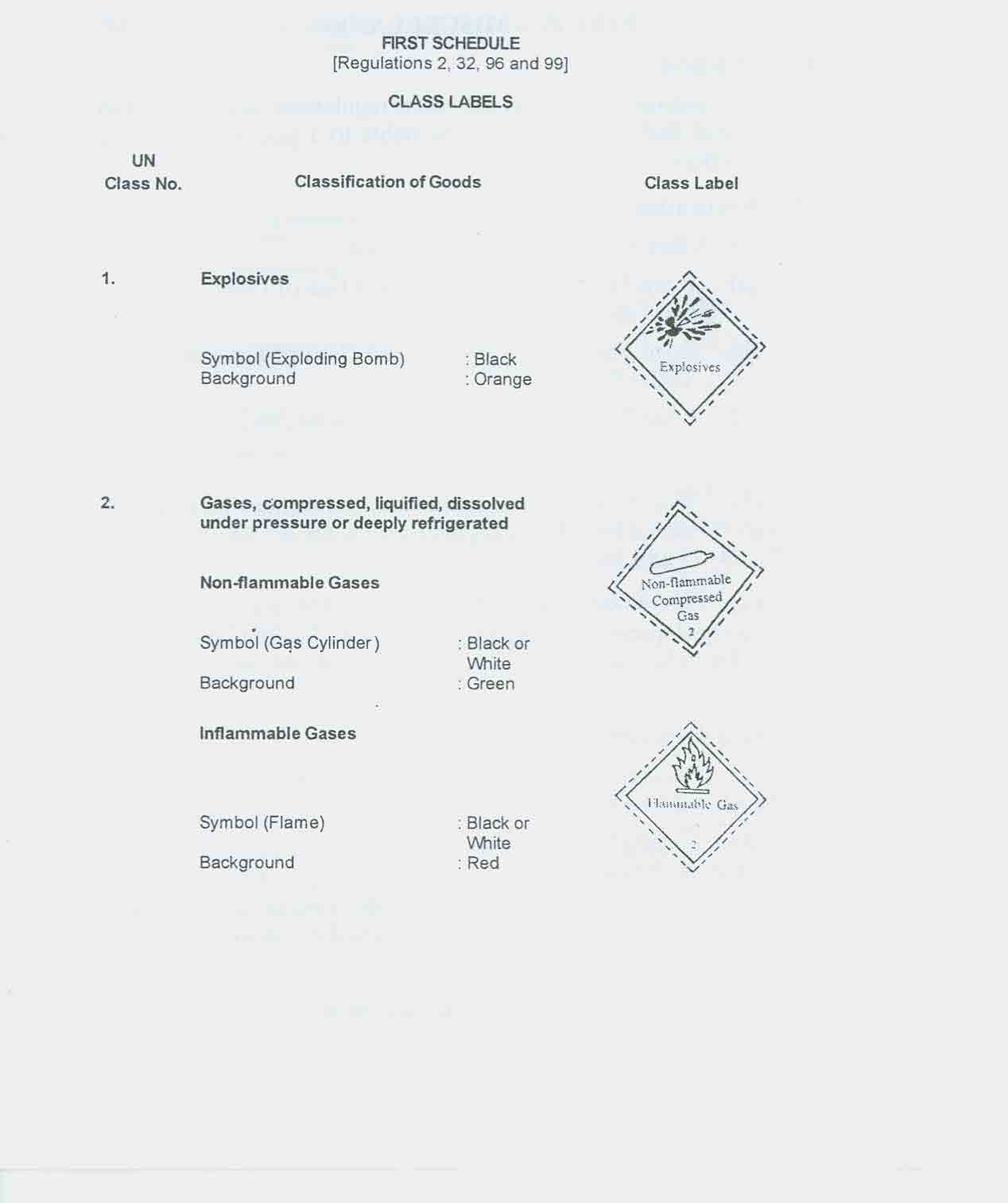
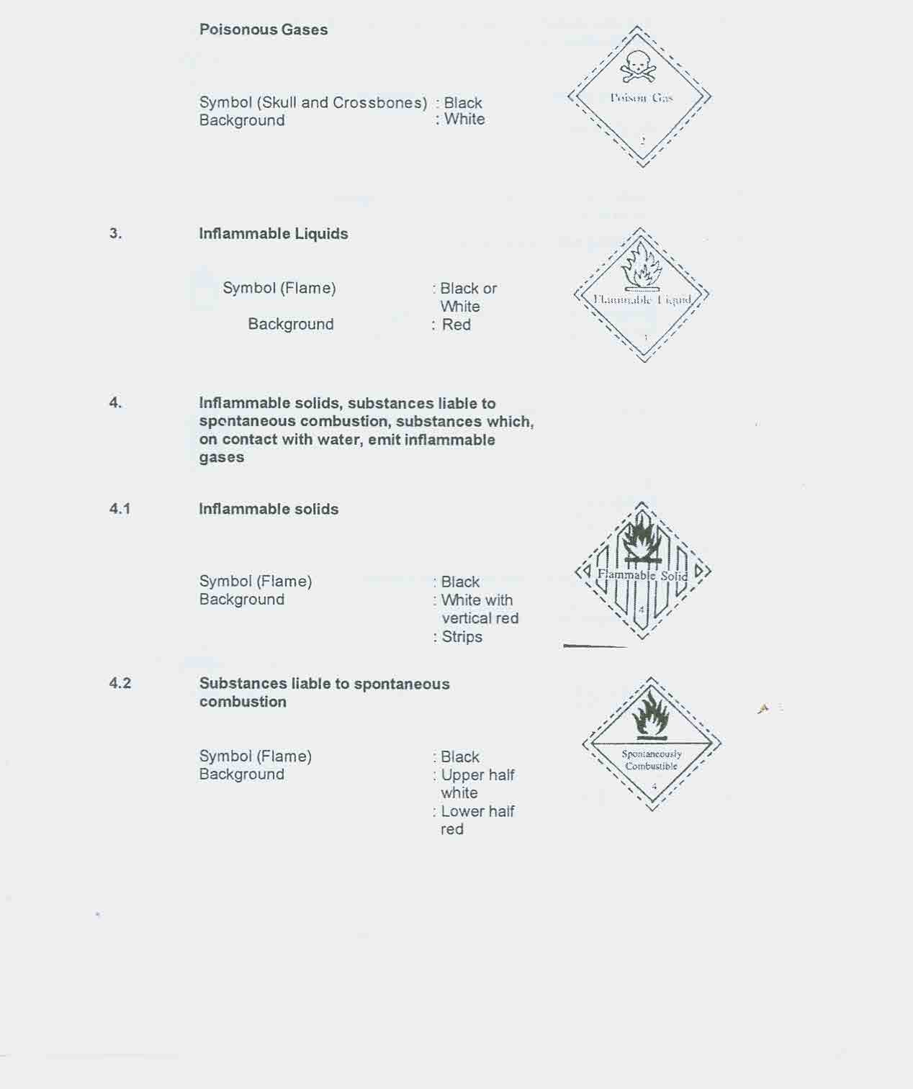
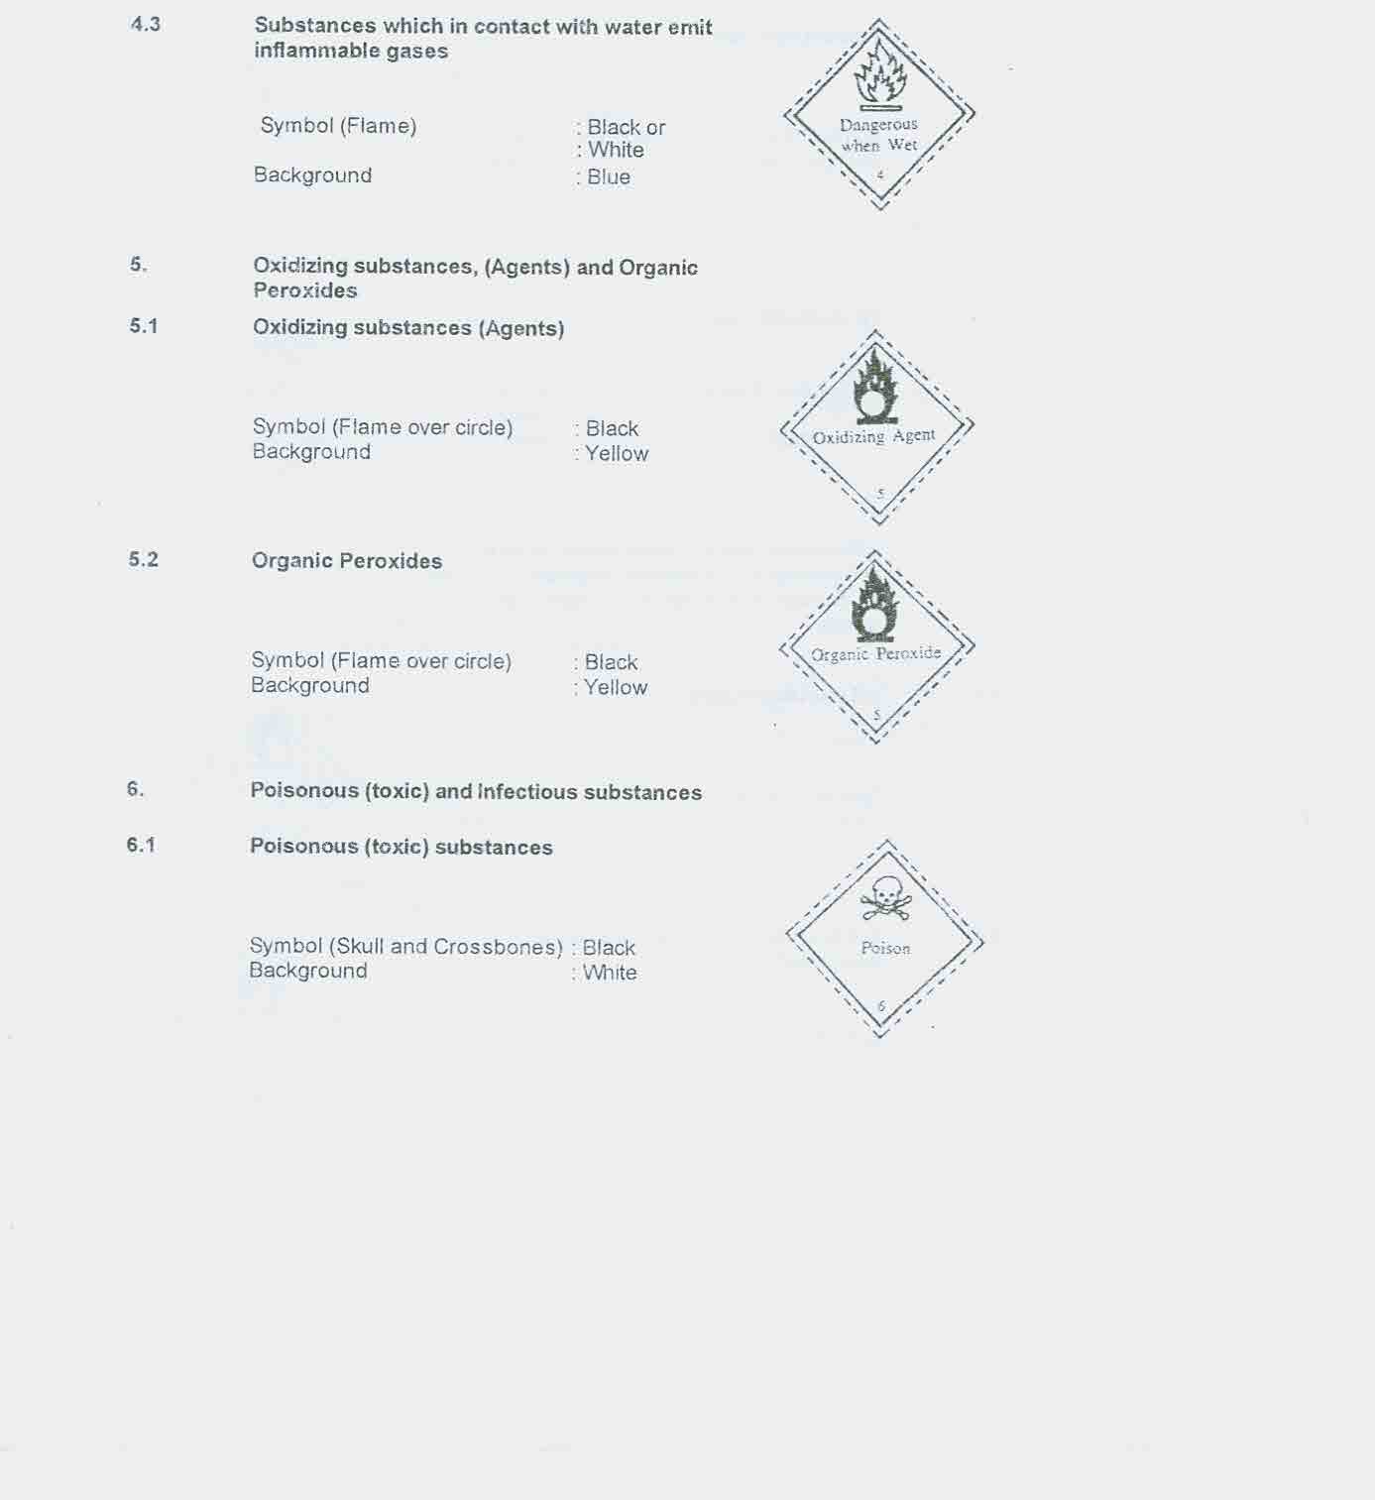
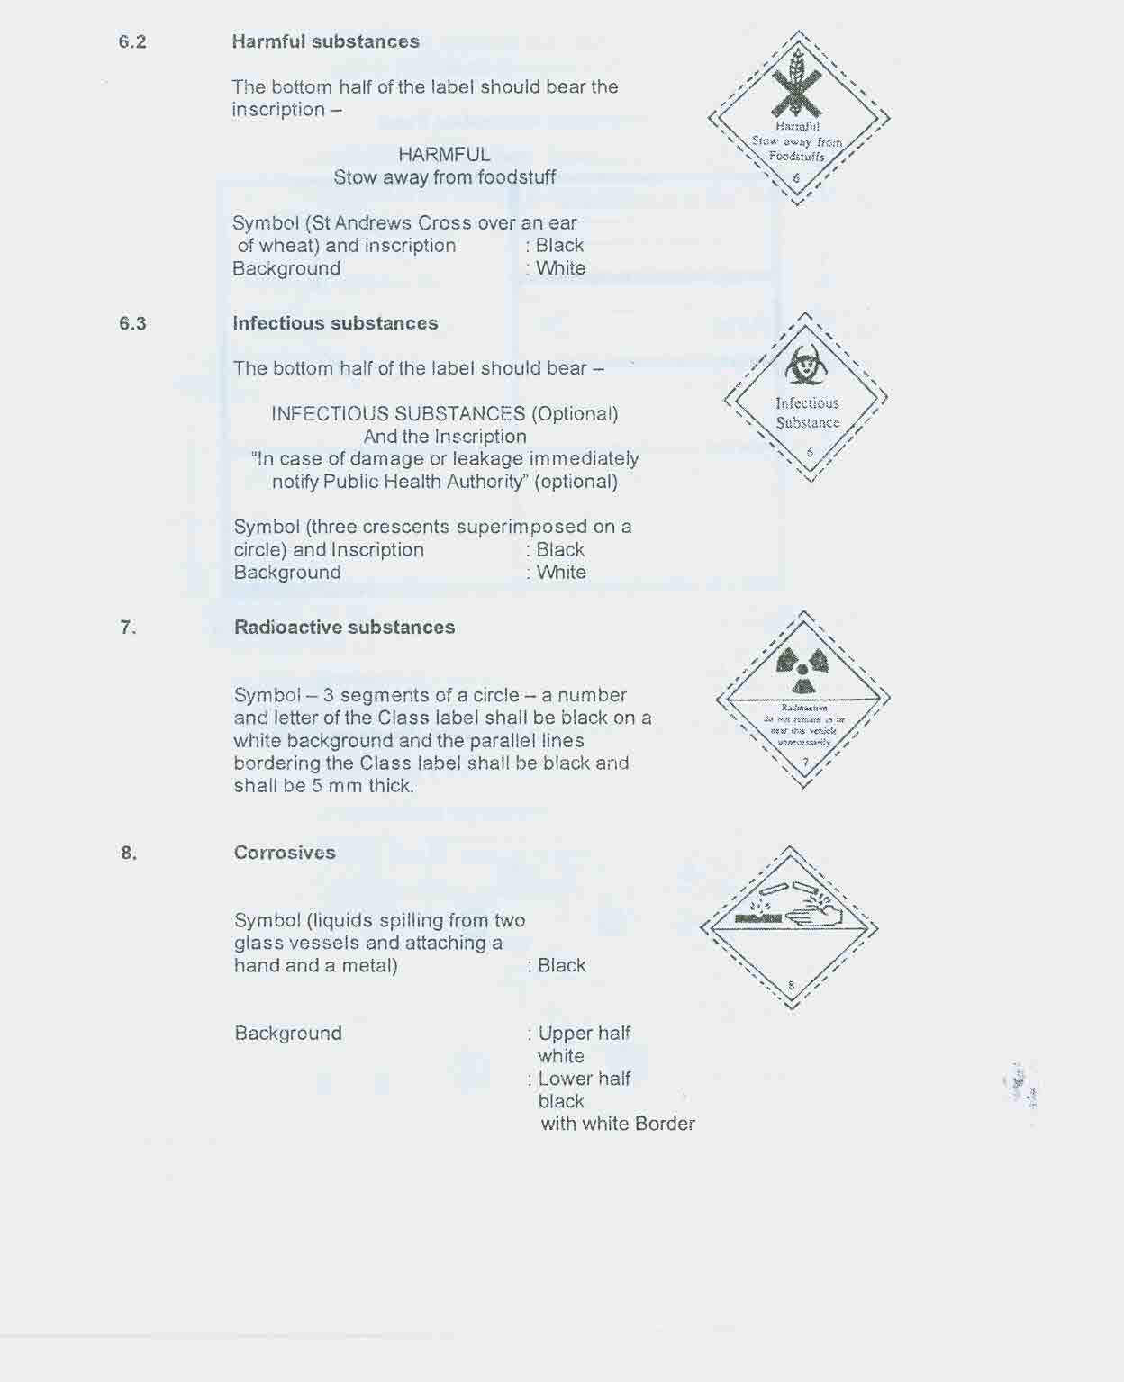
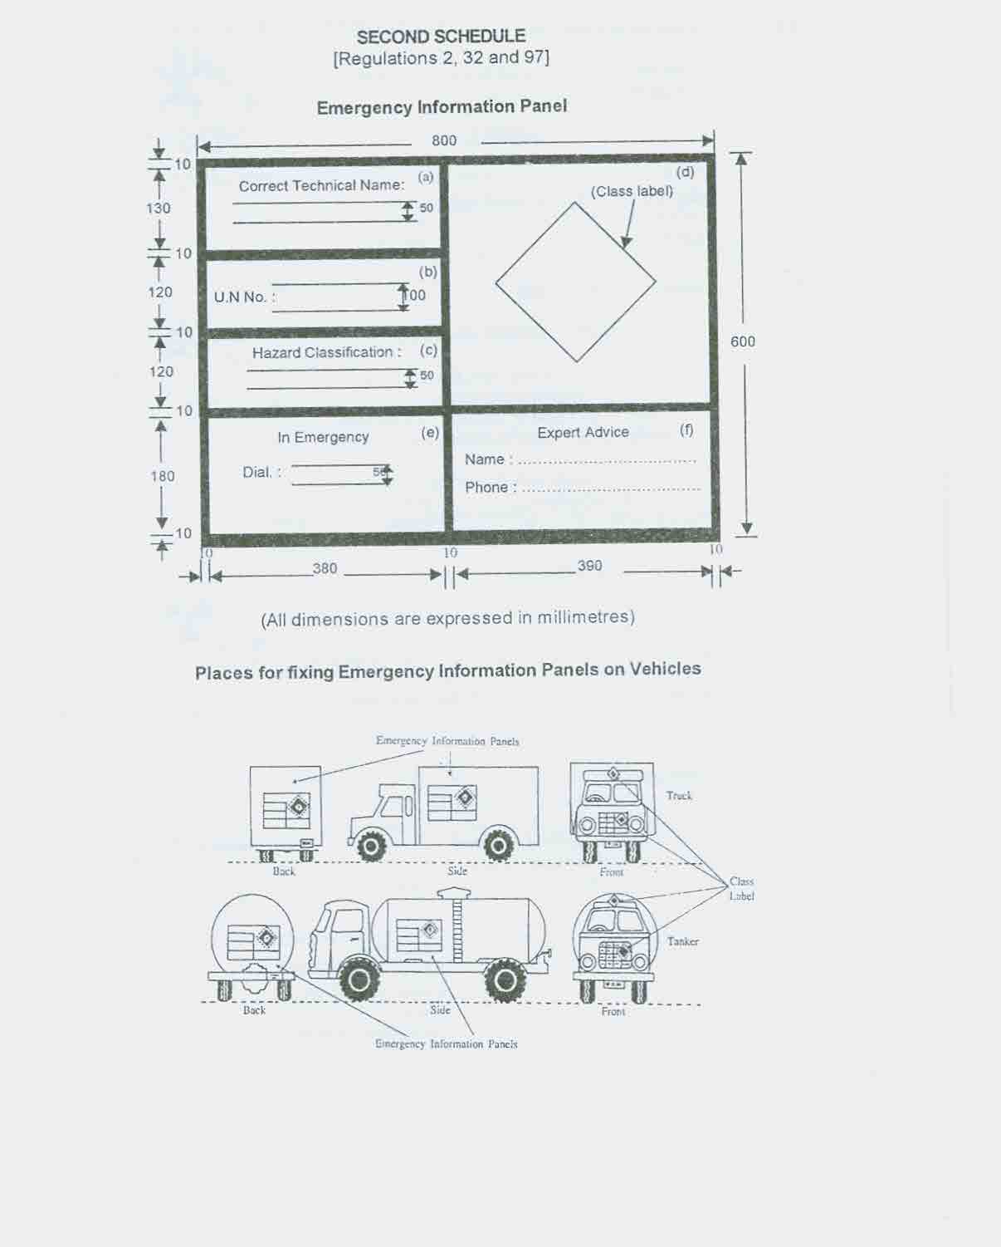
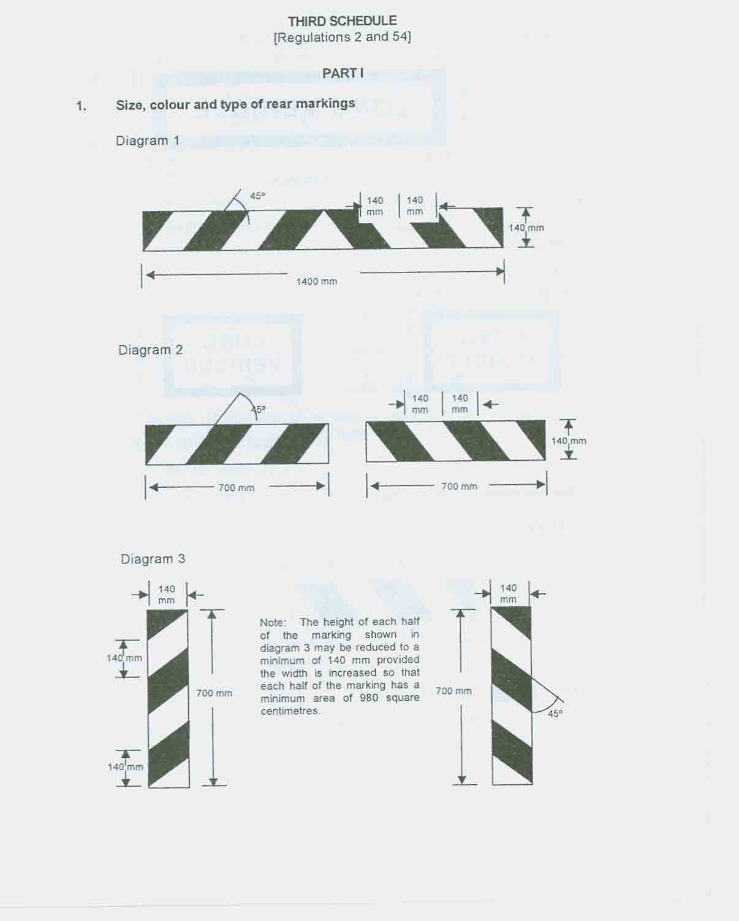
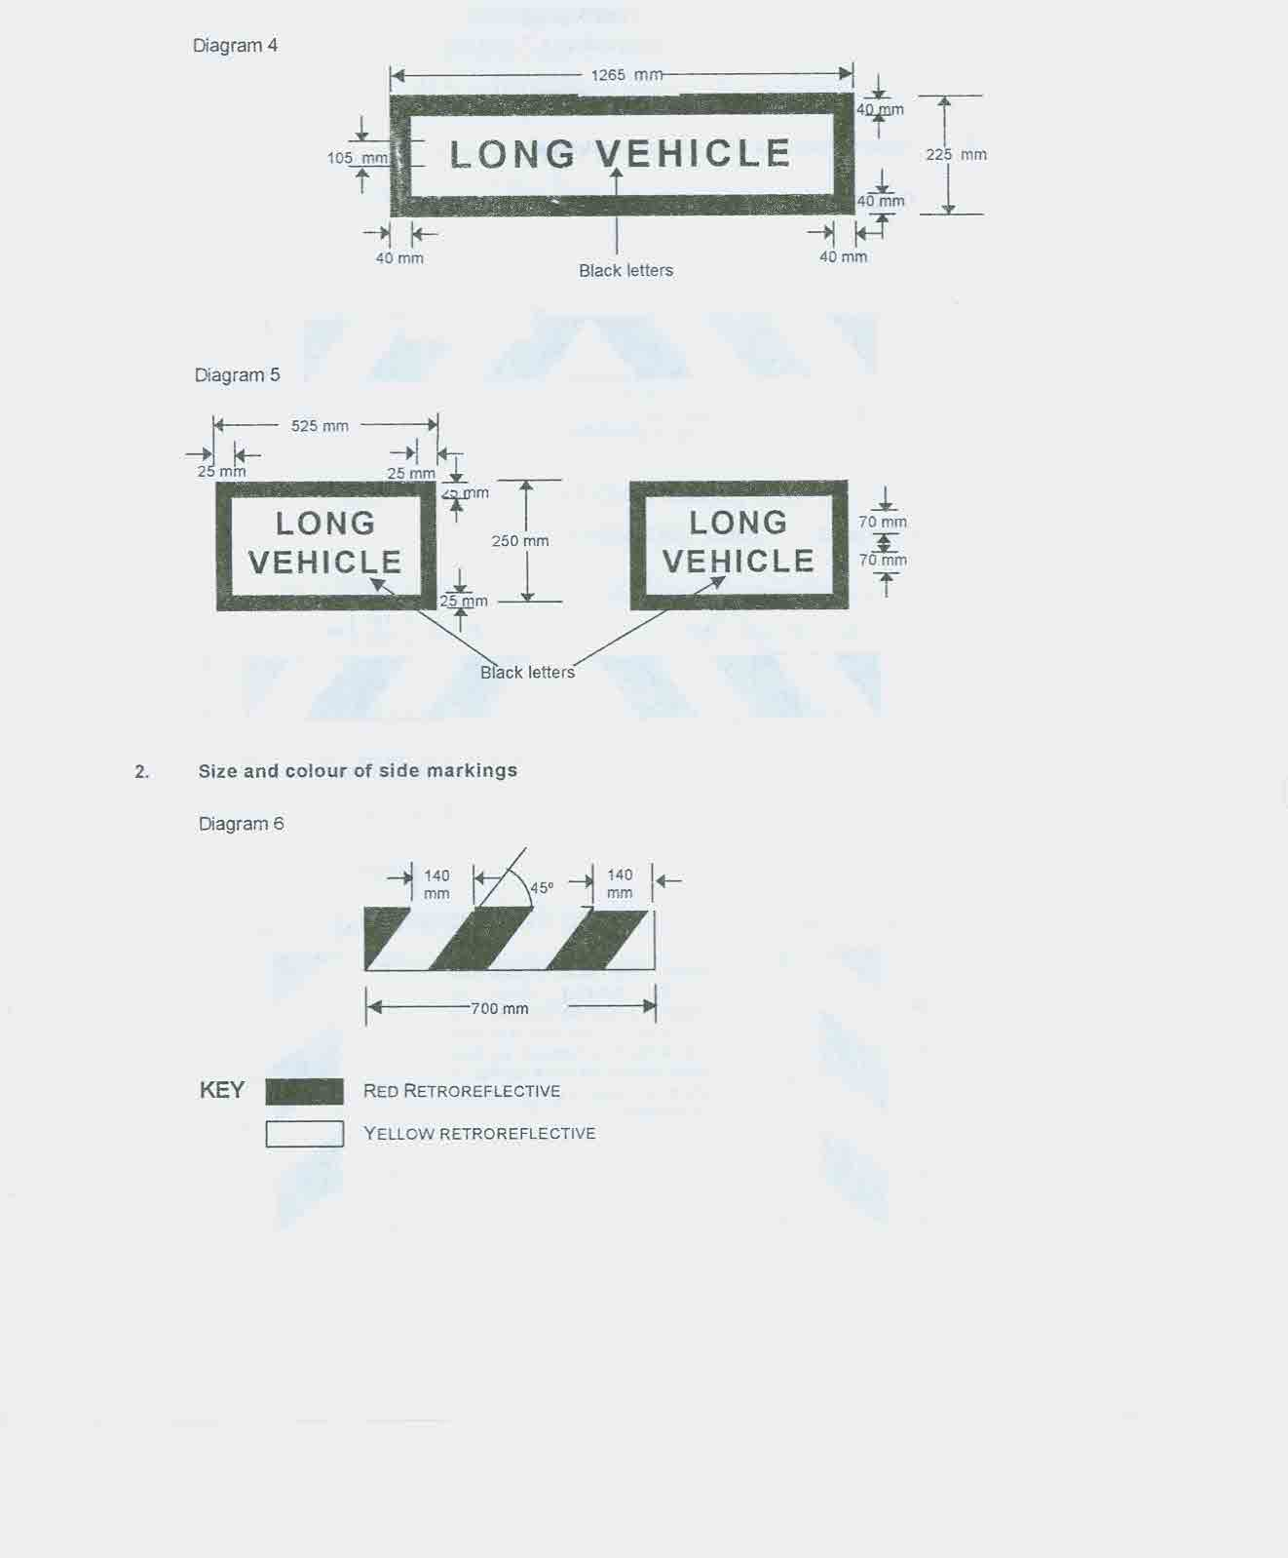
PART II
FORM OF REAR AND SIDE MARKINGS
1. Any variation in a dimension, other than as to the height of a letter, specified in any of the diagrams in Part I shall be treated as permitted for the purposes of these regulations if the variation -
(a) in the case of a dimension specified as 250 millimetres or over 250 millimetres, does not exceed 2½ per cent of that dimension;
(b) in the case of a dimension specified as 40 millimetres or over 40 millimetres but under 250 millimetres, does not exceed 5 per cent of that dimension; or
(c) in the case of a dimension specified as under 40 millimetres, does not exceed 10 per cent of that dimension.
2. Any variation in a dimension as to the height of a letter specified in any of the said diagrams shall be treated as permitted for the purposes of these regulations where the variation -
(a) in the case of a dimension specified as 105 millimetres, does not exceed 2½ per cent of that dimension; or
(b) in the case of a dimension specified as 70 millimetres, does not exceed 5 per cent of that dimension.
3. Any variation in a dimension as to the angle of hatching specified in any of the said diagrams shall be treated as permitted for the purposes of these regulations if the variation does not exceed 5 degrees.
4. Rear and side markings shall be illuminated by the use of red retro-reflective material in the shaded areas shown in any of the said diagrams and by the use of yellow retro-reflective material in any of the areas so shown, being areas not shaded and not constituting of letters.
5. A rear marking as in diagram 1 or 4 shall be constructed in the form of a single plate, and a rear marking as in diagram 2, 3 or 5 shall be constructed in the form of 2 plates of equal size and shape, and such plates shall be legibly and permanently marked with the specification number BS AU 152:1970 to indicate that the rear marking complies with the requirements laid down by the British Standard Institution's specification for Rear Marking Plates for Vehicles under the number BS AU 152:1970, or with some other appropriate mark for any other standard approved by the Commissioner.
6. All letters incorporated in any rear marking shall have the proportions and form of letters as shown in Part I and shall be coloured black.
7. Side markings shall be constructed in the form of a plate of the size and shape shown in paragraph B of Part I and comply with a standard approved by the Commissioner.
PART III
POSITION ON VEHICLE OF REAR AND SIDE MARKINGS
1. A rear marking shall be fitted in the positions indicated in Part I at the rear of the vehicle.
2. The lower edge of a rear marking shall be horizontal and so placed that it is not more than 1.1 metres nor less than 400 millimetres above ground level, and in the case of a rear marking as in diagram 2, 3 or 5, the lower edge of each half of the marking shall be at the same height above ground level provided that where, owing to the structure of the vehicle, it is impossible to fit the rear marking at such prescribed height, it shall be so fitted as near as possible to such height.
3. A rear marking as in diagram 2, 3 or 5 shall lie so that each half of the marking is as near as is practicable to the outermost edge of the vehicle on the side thereof on which it is fitted.
4. (a) A rear marking shall be so fitted that every part thereof is clearly visible at all times to other persons using the road within a reasonable distance to the rear of the vehicle.
(b) A side marking for a trailer shall be fitted on either side of the trailer as near as practicable to the front end without protruding beyond the trailer.
(c) A side marking shall be so fitted that every part thereof is clearly visible at all times to other persons within a reasonable distance to the side of the trailer.
5. The top edge of a side marking shall be at a height of not more than 800 millimetres and not less than 1.1 metres above ground level and shall stay within a plane parallel to the top level of the trailer.
6. Rear and side markings shall be securely attached to the vehicle so that no part of the markings projects beyond the outermost part of the vehicle on either side.
7. Rear and side markings shall be in a clean and efficient condition while the vehicle is on a road.

8. The direction of the diagonal stripes of every rear marking shall be as follows -
(a) all markings on the left of the centre-line of the vehicle shall slope downwards to the left; and
(b) all markings on the right of the centre-line of the vehicle shall slope downwards to the right.
_______________
FOURTH SCHEDULE
[Regulation 3]
PART I - BUSES
1. Interpretation
(1) In this Schedule -
"driver's door" means a door fitted to a bus for use by the driver;
"emergency exit" means an exit which is provided for use only by passengers in case of an emergency;
"entrance" means any aperture or space provided to enable passengers to board a bus;
"exit" means any aperture or space provided to enable passengers to leave a bus.
(2) Where, in this Schedule, a reference is made to a maximum or a minimum dimension, a tolerance of 10 millimetres shall apply to the dimension.
2. Notice of number of passengers
(1) There shall be conspicuously displayed inside every bus in figures of at least 75 millimetres high a notice stating the maximum number of passengers who may be carried on the vehicle in the following terms -
"CERTIFIED TO CARRY ............ PASSENGERS SEATED AND ….......... PASSENGERS STANDING"
(2) The number of passengers indicated on the notice referred to in sub-paragraph (1) shall be deemed to be the number of adult passengers the vehicle is permitted to carry.

3. Sides roof and floor
(1) The sides of every bus shall be made of durable and weather proof material and shall be enclosed to a height of -
(a) at least 830 millimetres from the floor in the case of an omnibus; and
(b) at least 630 millimetres from the floor in the case of a minibus.
(2) Every bus shall be provided with a watertight roof which shall -
(a) at all times be in good condition;
(b) be provided with -
(i) 4 air-vents in the case of a minibus; and
(ii) 6 air-vents in the case of an omnibus.
4. Entrances and exits
(1) Every single-decked omnibus to be registered in Mauritius shall be provided -
(a) on the near-side at the front of the vehicle, with one entrance which shall be -
(i) of an unobstructed width of not less than 530 millimetres;
(ii) of a height, of not less than 2.03 metres measured from the lowest step; and
(iii) equipped with sufficient handrails to provide adequate support to passengers entering the bus;
(b) with one emergency exit at the rearmost or offside of the vehicle, the lower edge of which is not more than 915 millimetres above the ground; and
(c) with one exit either at the centre or at the rear on the near side of the bus.
(2) (a) Every minibus to be registered in Mauritius shall be provided -
(i) on the near side of the vehicle, with at least one exit, not being an emergency exit, which may also be an entrance; and
(ii) at the rear of the vehicle, with an emergency exit or an emergency door.
(b) The entrance and exit door of a minibus shall be of a height of not less than 1.2 metres and shall be equipped with handrails to provide adequate support to passengers entering the bus.
(3) No bus shall be fitted on its offside with any door other than the driver's door and the emergency exit.
5. Emergency exits
(1) Every emergency exit of a bus shall -
(a) be clearly marked, as such, in letters of not less than 50 millimetres high inside and outside the bus;
(b) be fitted with a door which opens outwards and is capable of being operated manually;
(c) when fully opened, give an aperture in the body of the vehicle of not less than 1.2 metres high nor less than 700 millimetres wide;
(d) be easily accessible to passengers; and
(e) have an electrical sensor such that the driver is given audible and visual alarm when the door is not securely fastened.
(2) The means of operation of every emergency exit of a bus shall be clearly indicated.
(3) The means of operation of all doors of emergency exits shall be readily accessible to persons of normal height standing at ground level outside the vehicle.
6. Power-operated doors
(1) Every door of a bus having a seating capacity for more than 32 persons, excluding the driver, to be registered in Mauritius, shall be a power-operated door unless such door is used solely as an emergency exit or by the driver.
(2) Every power-operated door fitted to a bus shall -
(a) incorporate transparent panels so as to enable a person immediately inside the bus to see any person immediately outside the door;
(b) be capable of being operated by a mechanism controlled by the driver when in the driving seat;
(c) excepting emergency operation, only permit opening when the handbrake is applied and neutral gear is selected or the clutch is not depressed; and
(d) in case of an emergency or a failure of the supply of power for the operation of the door, be capable of being opened from both inside and outside the vehicle by controls which -
(i) override all other controls;
(ii) are placed on or adjacent to the door; and
(iii) are accompanied by markings which clearly indicate their position and methods of operation and warn that they are not to be used by passengers except in the case of an emergency.
(3) No bus shall be equipped with a system for the storage or transmission of energy in respect of the opening or closing of any door which is capable of adversely affecting the operation of the vehicle's braking system.
7. Doors
(1) Subject to sub-paragraph (3), no bus shall be fitted with -
(a) a door which can be locked from the outside unless, when so locked, it is capable of being opened from inside the vehicle when stationary;
(b) a handle or other device for opening any door, other than the driver's door, from inside the vehicle unless the handle or other device -
(i) is designed to prevent, so far as is reasonably practicable, the accidental opening of the door; and
(ii) is fitted with a guard or transparent cover so designed that it must be raised to open the door;
(c) a door which, when not locked, is not capable of being opened from inside and outside the vehicle by a single movement of the handle or other device for opening the door;
(d) a door without a device capable of holding it closed so as to prevent any passenger from falling through the doorway; or
(e) a side door which opens outwards.
(2) Every door of a bus shall operate so as not to obstruct door access to any entrance or exit from outside or inside the bus.
(3) Sub-paragraphs (1)(a), (c) and (d) shall not apply to a near side door forming part of a pair of doors capable of being held securely closed by the other door of that pair.
8. Steps, platform and stairs
(1) All steps of a bus shall be fitted with non-slip treads.
(2) The top of the tread of the lowest step or floor provided at any entrance or exit of a bus, other than an emergency exit, shall not be more than 280 millimetres above the ground.
(3) Every fixed step of a bus shall not project laterally beyond the body of the bus.
(4) The tread of each fixed step referred to in paragraph (3) shall be at least 230 millimetres deep and the riser of such fixed step shall be not more than 230 miIlimetres high.
(5) Every stage bus to be registered in Mauritius shall have a maximum of 2 steps between the passenger platform and the road.
9. Grab handles, handrails and hand-straps
(1) Every entrance and exit shall be fitted with a grab handle or a handrail to assist passengers to get on or off the vehicle.
(2) The backrest of every seat in a bus shall be fitted with a grab handle which shall extend across the full width of that seat and the distance between the lower edge of the handle and the top of the backrest shall be between 75 millimetres and 100 millimetres.
(3) Every bus shall have fitted to its roof a handrail running along the right-hand side of the entire aisle of the bus.
(4) Every handrail fitted to a bus to be registered in Mauritius, shall not be less than 30 millimetres in diameter.
(5) Every bus shall have a vertical post extending from the floor to the roof along its aisle at a maximum interval equivalent to twice the longitudinal distance between any seat and the seat directly ahead or behind but not exceeding 1.5 metres.
(6) When seats are positioned over a wheel arch or face inwards, a vertical post shall be positioned centrally in front of each row of such seat.
(7) Every handstrap fitted to a vehicle shall be attached to a handrail in such manner as not to enable it to slide along the handrail.
10. Passageways
(1) A bus shall be provided with a straight and unimpeded -
(a) gangway down the centre of the bus which shall, be -
(i) not less than 455 millimetres wide in the case of an omnibus; and
(ii) not less than 350 millimetres wide in the case of a minibus; and
(b) cross passageway from each entrance or exit of the bus to the gangway shall, subject to sub-paragraph (2) be -
(i) not less than 430 millimetres wide in the case of an omnibus; and
(ii) not less than 360 millimetres wide in the case of a minibus.
(2) A cross passageway which is in front of a seat shall be partitioned off to a height of at least 750 millimetres and to a maximum width of 450 millimetres.
11. Seats and seating arrangements
(1) No seat shall be fitted to any door of a bus.
(2) Every seat fitted to a bus shall be securely fixed to the floor of the vehicle.
(3) (a) Every passenger seat on a bus shall provide an adequate degree of comfort with suitable padded seat and seat back.
(b) The backrest of a seat shall have a padding of at least 50 millimetres thick and shall be at an angle of not less than 105°.
(4) (a) Subject to sub-paragraph (b), all passenger seats in a bus shall face forward.
(b) The seats over the wheel arches may face inwards and may be placed lengthwise.
(c) Where seats are placed lengthwise, the distance between any part of the backrest of any such seat and the corresponding part of the backrest of the seat facing it shall be at least 1.4 metres.
(d) The seating layout of every bus to be registered in Mauritius shall be 3 and 2, or 2 and 2, or one and 2, or one and one on either side of the aisle.
(5) No part of any seat on the left hand side of the seat of the driver in a bus shall be in front of a line passing through the front edge of the seat of the driver at right angles to the longitudinal axis of the vehicle, and such seat shall face forward.
(6) No seat shall be so placed as to reduce the width of the doorway or passage or cause discomfort to passengers.
(7) (a) The top of the backrest of every seat shall be -
(i) at least 450 millimetres from seat level, in the case of an omnibus; and
(ii) at least 380 millimetres from seat level, in the case of a minibus.
(b) The bottom of the backrest shall not be more than 150 millimetres from seat level.
(c) The width of the backrest including the frame shall -
(i) in the case of an omnibus, be at least 450 millimetres for every passenger for whom seating accommodation is provided on the seat; and
(ii) in the case of a minibus, be at least 380 millimetres.
(8) (a) Subject to sub-paragraph (b), the height of every seat from the floor to the top of the seat level shall not be less than 380 millimetres and not more than 500 millimetres.
(b) The height of a seat situated over any wheel arch shall not be less than 300 millimetres, in the case of a minibus.
(9) The depth of every seat from the front of the seat to the front of its backrest shall be -
(a) at least 400 millimetres in the case of an omnibus; and
(b) at least 350 millimetres in the case of a minibus.
(10) The width of every passenger seat shall be -
(a) at least 450 millimetres in the case of an omnibus; or
(b) at least 380 millimetres in the case of a minibus.
(11) Where seats face in the same direction, the horizontal distance between the front of the backrest of any such seat, at seat level, and the back of the backrest of the seat in front of the first-mentioned seat shall be -
(a) not less than 660 millimetres in the case of an omnibus; and
(b) not less than 600 millimetres in the case of a minibus.
(12) Where any seat faces a partition, the horizontal distance between the front of the backrest of such seat, at seat level, to such pa11ition or obstruction shall be -
(a) not less than 660 millimetres in the case of an omnibus; and
(b) not less than 600 millimetres in the case of a minibus.
(13) (a) Subject to subparagraph (b), no part of a wheel arch shall project vertically more than 75 millimetres beyond the floor of the seats.
(b) Subparagraph (a) shall not apply to a bus in which the seats constructed over the wheel arches face inwards.
12. Electrical circuit
No bus shall be fitted with any -
(a) electrical circuit which is liable to carry a current exceeding that for which it is designed; or
(b) cable for the conduct of electricity unless it is suitably insulated and protected from damage as to guard adequately against the risk of electric shock or the outbreak of fire.
13. Lighting
Every bus shall be provided with -
(a) in the case of a minibus, 4 fluorescent lights;
(b) in the case of an omnibus, 6 fluorescent lights.
14. Height of roof
(1) Subject to subparagraph (2), the height between the floor and the roof structure shall be measured along the centre of the gangway and shall be -
(a) not less than 1.8 metres in the case of an omnibus; and
(b) not less than 1.7 metres in the case of a minibus.
(2) The minimum height in the driving compartment of a bus shall be at least 1.6 metres.
15. Ventilation
(1) Every bus, other than a bus having a system of forced ventilation induced by a mechanical means, whether such bus is stationary or not, shall be fitted with at least 6 air-extractors which shall provide adequate ventilation inside the bus for passengers and the driver without the necessity for opening any main window or windscreen.
(2) Every bus equipped with an air conditioner, whether such bus is stationary or not, shall be fitted with 2 emergency louvers with electric fans which shall provide adequate ventilation inside the bus in case of failure of the air conditioning system.
16. Windows and windscreens
(1) Every bus -
(a) shall have a continuous row of windows on each side of the passenger compartment and the windows, other than the windows of the doors and the first and the last side window, shall each have a frame -
(i) of not less than 530 millimetres by 270 millimetres in the case of an omnibus; and
(ii) of not less than 400 millimetres by 350 millimetres in the case of a minibus;
(b) shall have an overall window area of not less than 25 per cent of the floor area of the passenger compartment; and
(c) may have other windows in addition to those referred to in this paragraph.
(2) At least every alternate window on each side of a bus, other than a bus having a system of forced ventilation induced by mechanical means, shall be capable of being opened.
(3) No window shall be capable of being opened in such a manner that a person seated in a normal position is able to put his elbow out of the window.
(4) Every side window of a single-decked bus with a permanent top shall have, to a height of not less than one metre above the deck level, rails or other adequate means which shall prevent a child from stretching his neck out of the window.
(5) Glass of all the windows located to the rearmost position of the driver's seat of a bus may have a visual transmission of light of not less than 35 per cent when measured perpendicular to the surface in accordance with the procedures specified in the operating manual of the device approved by the Minister under section 188A of the Road Traffic Act.
17. Driver’s accomodation
(1) Every bus shall be so designed that the driver, when sitting in his seat, has adequate room and can easily reach and operate the controls.
(2) Where a space is provided for any passenger on the left side of the seat of a driver in a bus, the space for the seat of the driver shall, except in the case of seat for a driving instructor, be divided off by means of a solid partition behind that seat and having a height of not less than one metre from the deck level, and by means of a continuation of the partition of the same height on the left of the seat and at least 460 millimetres from the centre of the steering column.
18. Driver's seat
(1) The seat of the driver shall be capable of being adjusted both horizontally and vertically and be so placed as to afford any driver ample space to safely operate all controls.
(2) There shall be a minimum distance of 200 millimetres between the rear of the seat of the driver and any partition when the seat is adjusted to its rearmost position.
19. Fuel tank
(1) No fuel tank of a bus shall be placed under any part of a gangway that is within 600 millimetres of any entrance or exit of a single-decked bus or the lower deck of a double-decker.
(2) The opening of the fuel tank shall be accessible only from the outside of the bus and shall be placed to the inside of the body of the bus.
(3) The filler cap to the fuel tank shall be so designed and constructed that it cannot be dislodged by accidental operation.
(4) No fuel tank shall be placed close to the engine or the exhaust system of a bus.
(5) The fuel tank and fuel pipes supplying fuel to the engine of a bus shall be free from any leak and shall not be placed inside the compartment or other spaces provided for the accommodation of the driver or passengers.
20. Mirrors
Every bus shall, in addition to the rearview mirror prescribed for all motor vehicles, be fitted with a convex mirror located in such a way as to enable the driver, when in the seat of the driver, to see a reflection of every door of the bus.
21. Destination indicators
(1) Every bus with a stage bus licence shall be fitted to the front and to the rear with an electronic indicator measuring at least 1.3 metres wide by 330 millimetres high and on top of the entrance door with a destination indicator of a type to be approved by the Commissioner.
(2) The destination indicator shall -
(a) indicate clearly the route to be followed by and the destination of the bus; and
(b) be illuminated during the hours of darkness.
22. Persons to be able to signal to driver
Efficient means, in the form of a bell or light functioning by means of a press button shall be provided in every bus to enable any passenger to signal to the driver to stop.

23. Wireless apparatus
No wireless receiving apparatus or sound transmitting apparatus shall be fitted to a bus except with the written permission of the Commissioner.
24. Doors to be fitted with a sound-producing device
(1) Every door, except that provided solely for use during an emergency or for the driver, of a bus licensed as a school-owned or a school (hired) bus shall be fitted with a device for producing a sound when the door is not fully closed.
(2) The device shall be fitted near the seat of the driver and within the interior of the bus so that any sound produced by the device is mainly confined within the bus.
(3) The sound emitted by the device shall be sufficiently loud to warn the driver and any passenger of the bus that the door is not fully closed, but shall not be unduly harsh, shrill, loud or alarming.
(4) The owner and the driver of a school-owned bus or a school (hired) bus shall ensure that the device connected to its door is in proper working conditions at all times.
(5) Any person who modifies or tampers with the working of the device in a manner that is likely to prevent the device from producing a sound when the door is not fully closed shall commit an offence.
PART II
GOODS VEHICLES
1. Size and weight
(1) Subject to subparagraph (2), the part of the box which overhangs shall not exceed 45 per cent of the total length of the box.
(2) The overhang of the box referred to in subparagraph (1) may be exceeded by not more than 250 millimetres where the payload of a goods vehicle is decreased by 20 per cent.
(3) Where a vehicle is fitted with double rear wheels, no part of the vehicle shall project more than 75 millimetres beyond the external edges of the tyres of the outer rear wheels.
(4) The maximum axle weight of the sole driving axle or of any other single axle of a vehicle shall not exceed 10,200 kilograms.
(5) The maximum axle weight of any steering axle shall not exceed 5,000 kilograms.
(6) The sum of the axle weights of a tandem axle shall not exceed -
(a) 10,200 kilograms if the axle spacing is less than one metre;
(b) 16,300 kilograms if the axle spacing is less than 1.3 metres;
(c) 18,300 kilograms if the axle spacing is less than 1.8 metres; and
(d) 20,300 kilograms if the axle spacing is 1.8 metres or more.
(7) The sum of the axle weights of a triaxle shall not exceed -
(a) 20,300 kilograms where the spacing between the individual axles is less than 1.3 metres; or
(b) 24,400 kilograms where the spacing between the individual axles is less than 1.3 metres and 1.4 metres.
(8) Subject to the number of axles, the maximum gross weight of any motor vehicle shall not exceed -
(a) for any 2-axle vehicle 15,000 kilograms;
(b) for any 3-axle vehicle 25,000 kilograms;
(c) for any 4-axle vehicle 32,000 kilograms;
(d) for any 5-axle vehicle 38,000 kilograms;
(e) for any 6-axle vehicle 43,000 kilograms; and
(f) for any 7-axle vehicle 48,000 kilograms.
(9) Every goods vehicle licensed to carry a container shall be fitted with at least a tandem axle.
2. Steering mechanism
Every goods vehicle, with a maximum laden weight of more than 3,500 kilograms, to be registered in Mauritius shall be equipped with a power assisted steering mechanism.
3. Goods vehicle fitted with a permanent enclosed body
(1) The Commissioner may require any goods vehicle to have a partition constructed immediately behind the seat of the driver at right angles to the longitudinal axis of the vehicle.
(2) The partition referred to in subparagraph (1) shall be of such specification as the Commissioner may reasonably require.
4. Protective railings
(1) Every goods vehicle which has an open deck and is of a maximum laden weight of not more than 3,500 kilograms shall be fitted with protective railings along the whole length of the side panels on both sides of the vehicle up to a length of not less than 700 millimetres from the carriage deck and not less than 300 millimetres from the top of the side panels.
(2) The railings referred to in subparagraph (1) shall be constructed of metal or timber of such strength and size as the Commissioner may approve, and shall be securely and rigidly fixed to the side panels.

5. Headboard
(1) A headboard shall be fitted along the full width at the front end of the deck of every flat bed truck, trailer or semi-trailer and at a height of at least 700 millimetres above the deck.
(2) The headboard shall be capable of restraining from forward movement the full weight of the load, if any.
6. Weight and load to be painted on vehicle
The unladen weight and the payload of a goods vehicle shall be displayed in a conspicuous place on the nearside and rear-side of the vehicle.
7. Vehicles transporting persons
(1) The holder of a carrier's licence may apply to the Authority for the conveyance of more than 8 persons in his vehicle.
(2) Where the Authority grants an application under subparagraph (1), the licensee shall ensure that his vehicle -
(a) is fitted with properly constructed and properly secured seats at not less than 300 millimetres from the top of the box and allowing a floor space of 0.20 square metres per person;
(b) is fitted with poles or stanchions as supports for a tarpaulin; and
(c) carries a tarpaulin in case of need.
(3) Where a licensee or any driver employed by him fails to comply with any of the conditions of the preceding subparagraph, both the licensee and the driver shall commit an offence.
(4) Any person carried in a goods vehicle under this paragraph who fails to occupy a seat provided under subparagraph (2)(a) shall commit an offence.
FIFTH SCHEDULE
[Regulation 6(4)]
PART I
1. Advance notice
(1) The owner of a vehicle to which this Part applies, shall, before using it on a road, give notice of its intended use to the Commissioner of Police.
(2) The notice shall, subject to subparagraph (3), reach the Commissioner of Police at least 15 days before the date on which the vehicle is to be used, and shall include the following details -
(a) time, date and itinerary of the proposed journey; and
(b) the overall length and width of the vehicle by which the load is to be carried and the width of the lateral projection or projections of its load; or
(c) the overall length and width of each vehicle by which the load is to be carried, the length of any forward or rearward projection and, where the load will rest on more than one vehicle, the distance between the vehicles; or
(d) the overall length of the combination of vehicles and the length of any forward or rearward projection of the load; or
(e) the overall length of the vehicle and the length of any forward or rearward projection of the load or special appliance or apparatus.
(3) The Commissioner of Police may, at his discretion, accept a shorter period of notice.
(4) The vehicle shall be used only in accordance with the details furnished in accordance with subparagraph (2), subject to any variation in the time, date, route or conditions which may be determined by the Commissioner of Police.
2. Attendants
In addition to the driver of the motor vehicle to which this Part applies, at least one person shall be employed -
(a) in attending to the vehicle and its load and any other vehicle or vehicles drawn by it and the load or loads carried on the vehicle or vehicles so drawn;
(b) to give warning to the driver and to any person of any danger likely to be caused to any such other person by reason of the presence of the vehicle or vehicles on the road; and
(c) for giving assistance to the driver in case of illness and to summon help.
3. Marking of projections
(1) Every rearward projection of a load on a vehicle to which this Part applies shall be fitted with an end-marker which shall be of the size, shape and colour described in Part II of this Schedule.
(2) The rear marker shall be so fitted that -
(a) it is not more than 300 millimetres inward from the extreme end of the projection;
(b) the vertical distance between the lowest point of the marker and the road surface is not more than 2.5 metres;
(c) it does not impede the view of the driver and
(d) it is clearly visible within a reasonable distance to a person using the road.
(3) Every marker fitted in accordance with this paragraph shall be kept -
(a) clean and unobscured;
(b) be fluorescent; and
(c) during the hours of darkness, be illuminated by a lamp which renders it readily visible from a reasonable distance and which is so shielded that its light, except as reflected from the marker, is not visible to other persons using the road.
PART II
END MARKER
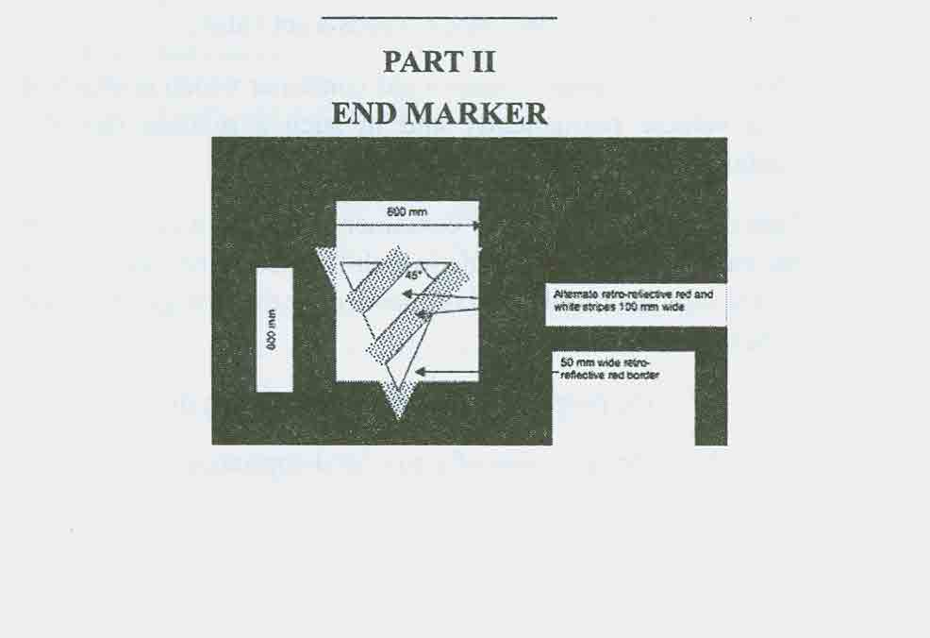

SIXTH SCHEDULE
[Regulation 31]
GAS SYSTEMS
1. Definitions
In this Schedule -
"check valve" means a device which permits the flow of gas in one direction and prevents the flow of gas in the opposite direction;
"design pressure" means the pressure which a gas system can safely withstand;
"double-check valve" means a device which consists of 2 check valves in series which permits the flow of gas in one direction and prevents the flow of gas in the opposite direction;
"excess flow valve" means a device which automatically and instantaneously reduces to a minimum the flow of gas through the valve when the flow rate exceeds a set value;
"fixed gas container" means a gas container which is attached to a vehicle permanently and in such a manner that the container can be filled without being moved;
"gas container" means any container, not being a container for the carriage of gas as goods, which is fitted to or carried on a motor vehicle or trailer and is intended for the storage of gas for either -
(a) the propulsion of the motor vehicle; or
(b) the operation of a gas-fired appliance;
"gas-fired appliance" means a device in a motor vehicle or trailer which consumes gas, other than the engine of the motor vehicle or an acetylene lamp;
"high pressure" means a pressure exceeding 1.0325 bar absolute;
"high pressure pipeline" means a pipeline intended to contain gas at high pressure;
"pipeline" means any pipe or passage connecting any 2 parts of a gas propulsion system of a vehicle or of a gas-fired appliance supply system on a vehicle;
"pressure relief valve" means a device which opens automatically when the pressure in the gas system to which it is fitted exceeds a set value, reaches its maximum flow capacity when the set value is exceeded by 10 per cent and closes automatically when the pressure falls below a set value; and
"reducing valve" means a device which automatically reduces the pressure of the gas passing through it.
2. Gas containers
(1) Every gas container shall -
(a) be capable of withstanding the pressure of the gas which may be stored in the container at the highest temperature which the gas is likely to reach;
(b) when fitted inside a vehicle, be so arranged as to prevent, so far as is practicable, the possibility of gas entering the engine, passenger or living compartments due to leaks or venting from the container or valves, connections and gauges immediately adjacent to it, and the space containing these components shall be so ventilated and drained as to prevent the accumulation of gas;
(c) be securely attached to the vehicle in such a manner as not to be liable to displacement or damage due to vibration or other cause; and
(d) be so placed and so insulated or shielded as not to suffer any adverse effect from the heat of the exhaust system of any engine or any other source of heat.
(2) Every fixed gas container shall be -
(a) fitted with at least one pressure relief valve; and
(b) conspicuously and permanently marked with its design pressure.
(3) Where the operation of any pressure relief valve referred to in sub-paragraph (2) may cause gas to be released from the gas container, an outlet shall be provided to lead such gas to the outside of the vehicle so as not to suffer any adverse effect from the heat of the exhaust system of any engine or any other source of heat, and that outlet from the pressure relief valve shall not be fitted with any other valve or cock.
3. Filling systems for fixed gas containers
(1) Every connection for filling a fixed gas container shall be on the outside of the vehicle.
(2) There shall be fitted to every fixed gas container -
(a) a manually operated shut-off valve and an excess flow valve;
(b) a manually operated shut-off valve and a single check valve; or
(c) a double-check valve,
and all parts of these valves in contact with gas shall be made entirely of suitable metal except that they may contain non-metal washers and seals, provided that such washers and seals are supported and constrained by metal components.
(3) In every case where a pipe is attached to a gas container for the purpose of filling the gas container there shall be fitted to the end of the pipe furthest from the gas container a check valve or a double-check valve.
(4) There shall be fitted over every gas filling point on a vehicle a cap which shall -
(a) prevent any leakage of gas from the gas filling point;
(b) be secured to the vehicle by a chain or some other suitable means;
(c) be made of suitable material; and
(d) be fastened to the gas filling point by either a screw thread or other suitable means.
4. Pipelines
(1) Every pipeline shall be fixed in such a manner and position that -
(a) it will not be adversely affected by the heat of the exhaust system of any engine or any other source of heat;
(b) it is protected from vibration and strain in excess of that which it can reasonably be expected to withstand; and
(c) in the case of a high pressure pipeline it is so far as is practicable accessible for inspection.
(2) Subject to subparagraph (4), every high pressure pipeline shall be -
(a) a rigid line of steel, copper or copper alloy of high pressure hydraulic grade, suitable for service on road vehicles and designed for a minimum service pressure rating of not less than 75 bar absolute; and
(b) effectively protected against, or shielded from, or treated so as to be resistant to, external corrosion throughout its length unless it is made from material which is corrosion resistant under the conditions which it is likely to encounter in service.
(3) No unsupported length of any high pressure pipeline shall exceed 600 millimetres.
(4) Flexible hose may be used in a high pressure pipeline where -
(a) it is reinforced either by stainless steel wire braid or by textile braid;
(b) its length does not exceed 500 millimetres; and
(c) save in the case of a pipeline attached to a gas container for the purpose of filling that container the flexibility which it provides is necessary for the construction or operation of the gas system of which it forms a part.
(5) Where a high pressure pipeline is so constructed or located that it may, in the course of its normal use, excluding the supply of fuel from a gas container, contain liquid which is prevented from flowing, a relief valve shall be incorporated in that pipeline.
5. Unions and joints
(1) Every union and joint on a pipeline or gas container shall be so constructed and fitted that it will -
(a) not be liable to work loose or leak when in use; and
(b) be readily accessible for inspection and maintenance.
(2) Every union on a high pressure pipeline or on a gas container shall be made of suitable metal but such a union may contain non-metal washers and seals provided that such washers and seals are supported and constrained by metal components.
6. Reducing valves
Every reducing valve shall be made of suitable materials and be so fitted as to be readily accessible for inspection and maintenance.
7. Pressure relief valves
(1) Every pressure relief valve which is fitted to any part of a gas system, including a gas container, shall -
(a) be made entirely of suitable metal and so constructed and fitted as to ensure that the cooling effect of the gas during discharge shall not prevent its effective operation;
(b) be capable, under the most extreme temperatures likely to be met, including exposure to fire, of a discharge rate which prevents the pressure of the contents of the gas system from exceeding its design pressure;
(c) have a maximum discharge pressure not greater than the design pressure of the gas container;
(d) be so designed and constructed as to prevent unauthorised interference with the relief pressure setting during service; and
(e) have outlets which are -
(i) so sited that so far as is reasonably practicable in the event of an accident the valve and its outlets are protected from damage and the free discharge from such outlets is not impaired; and
(ii) so designed and constructed as to prevent the collection of moisture and other foreign matter which could adversely affect their performance.
(2) The pressure at which a pressure relief valve is designed to start lifting shall be clearly and permanently marked on every such valve.
(3) Every pressure relief valve which is fitted to a gas container shall communicate with the vapour space in the gas container and not with any liquefied gas.
8. Valves and cocks
(1) Subject to paragraph (2), a valve or cock shall be fitted to every supply pipeline as near as practicable to every fixed gas container and such valve or cock shall, by manual operation, enable the supply of gas from the gas container to the gas system to be stopped and shall -
(a) where it is fitted on the outside of the vehicle, be readily visible and accessible from the outside of the vehicle; or
(b) where it is fitted inside the vehicle be readily accessible for operation and be so arranged as to prevent so far as is practicable the possibility of gas entering the engine, passenger or living compartments due to leaks, and the space containing the valve or cock shall be so ventilated and drained as to prevent the accumulation of gas in that space.
(2) Where a fixed gas container supplies no gas system, other than a gas propulsion system, and the gas container is so located that it is not practicable to make the valve or cock referred to in subparagraph (1) readily accessible, there shall be fitted an electrically-operated valve which shall either be incorporated in the valve or cock referred to in subparagraph (1) or be fitted immediately downstream from it and shall -
(a) be constructed so as to open when the electric power is applied and to close when the electric power is cut off;
(b) be so fitted as to shut off the supply of gas from the gas container to the gas system when the engine is not running; and
(c) when fitted inside the vehicle be so arranged as to prevent, as far as is practicable, the possibility of gas entering the engine, passenger or living compartments due to leaks, and the space containing the valve shall be so ventilated and drained as to prevent the accumulation of gas in that space.
(3) A notice clearly indicating the position, purpose and method of operating every valve or cock referred to in subparagraphs (1) and (2) shall be fixed -
(a) in all cases, in a conspicuous position on the outside of the vehicle, and
(b) in every case where the valve or cock is located inside the vehicle in a conspicuous position adjacent to the gas container.
(4) In the case of a high pressure pipeline for the conveyance of gas from the gas container an excess flow valve shall be fitted as near as practicable to the gas container and such valve shall operate in the event of a fracture of the pipeline or other similar failure.
(5) All parts of every valve or cock referred to in this paragraph which are in contact with gas shall be made of suitable metal, save that they may contain non-metal washers and seals provided that such washers and seals are supported and constrained by metal components.
9. Gauges
Every gauge connected to a gas container or to a pipeline shall be so constructed as to be unlikely to deteriorate under the action of the gas used or to be used and shall be so constructed and fitted that -
(a) no gas can escape into any part of the vehicle as a result of any failure of the gauge; and
(b) except in the case of a gauge fitted as an integral part of a gas container, in the event of any failure of the gauge, the supply of gas to the gauge can be readily stopped.
10. Propulsion systems
(1) Every gas propulsion system shall be so designed and constructed that -
(a) the supply of gas to the engine is automatically stopped by the operation of a valve when the engine is not running at all or is not running on the supply of gas; and
(b) where a reducing valve is relied on to comply with subparagraph (a), the supply of gas to the engine is automatically stopped by the operation of an additional valve when the engine is switched off.
(2) Where the engine of a vehicle is constructed or adapted to run on one or more fuels as alternatives to gas, the safety and efficiency of the engine and any fuel system shall not be impaired by the presence of any other fuel system.
11. Gas-fired appliances
(1) Every part of a gas-fired appliance shall be -
(a) so designed and constructed that leakage of gas is unlikely to occur; and
(b) constructed of materials which are compatible both with each other and with the gas used.
(2) Every gas-fired appliance shall be -
(a) so located as to be easily inspected and maintained;
(b) so located and either insulated or shielded that its use shall not cause or be likely to cause danger due to the presence of any flammable material;
(c) so designed and located as not to impose undue stress on any pipe or fitting; and
(d) so fastened or located as not to work loose or move in relation to the vehicle.
12. General requirements
Every part of a gas propulsion system or a gas-fired appliance system, excluding the appliance itself, shall be -
(a) so far as is practicable so located or protected as not to be exposed to accidental damage;
(b) soundly and properly constructed of materials which are compatible with one another and with the gas used or to be used and which are capable of withstanding the loads and stresses likely to be met in operation; and
(c) so designed and constructed that leakage of gas is unlikely to occur.
SEVENTH SCHEDULE
[Regulation 48]
WATTAGE AND NUMBER OF LAMPS/BULBS
 | Watts |  | Number
 | Minimum | Maximum | Minimum | Maximum
Main beam headlamps | 30 | 75 | 2 | 2
Dip beam headlamps | 30 | 75 | 2 | 2
Front parking lights | 5 | 7 | 2 | 4
Rear parking/taillights | 5 | 7 | 2 | 4
Front fog lights | 30 | 60 | - | 2
Rear fog lights | 15 | 24 | - | 2
Brake lights - vehicles under  3,500 kg | 15 | 36 | 2 | 4
Brake lights - vehicles over  3,500 kg | 25 | 50 | 2 | 4
Reversing lights | 15 | 24 | 1 | 2
Registration plate light | 2 | 5 | 1 | 2
Direction indicators - vehicles  under 3,500 kg | 15 | 36 | 4 | 3 pairs
Direction indicators - vehicles  over 3,500 kg | 20 | 36 | 4 | 3 pairs
Hazard lights | 20 | 36 | 4 | 3 pairs
Lorry/bus identification lamps | 5 | 20 | 2 | 4
Beacon lamps | 30 | 60 | 1 | 1

NINTH SCHEDULE
[Regulations 58 and 59]
SIZE AND SPACING OF CHARACTERS ON REGISTRATION PLATES
PART I
 | Registration plate for motor vehicle or  trailer | Registration plate for auto cycle or motorcycle
Height of character | 79 mm | 64 mm
Width of every part of the stroke  forming a character | 14 mm | 10 mm
Width of character (other than  the letter "I" and number "1") | 50 mm | 44 mm
Space between any 2 characters  within a group | 11 mm | 10 mm
Horizontal space between  groups of characters | 33 mm | 30 mm
Vertical space between groups  of characters | 19 mm | 13 mm
Width of margin between the registration mark and the top, bottom and side edges of registration plate | 11 mm | 11 mm
____________
PART II
Description of registration mark | Permitted layouts
A single letter or group of 2 letters followed by a group of not more than 4 numbers (e.g. A 1234, AB 1234) | Diagrams 1a and 1b
A group of not more than 4 numbers followed by a single letter or a group of 2 letters (e.g. 1234 A, 1234 AB) | Diagrams 2a and 2b
A group of not more than 4 numbers followed by a group of 2 letters and a second group of 2 numbers (e.g. 9999 DC 09) | Diagrams 3a and 3b
A group of not more than 3 letters followed by 8 group of not more than 4 numbers (e.g. ABC 1234, AB 123, A 12) | Diagrams 4a and 4b
A group of 3 letters followed by a group of 1 number and 1 letter | Diagrams 5a and 5b

