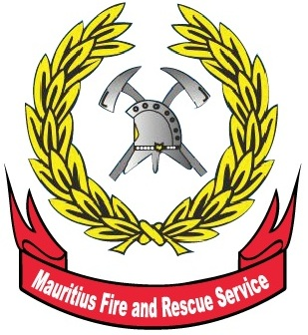

Mauritius

Fire and Rescue Service

Statistical Report 2013

May 2014
TABLE OF CONTENTS

3 | Introduction
8 | Table 1 - Monthly average time taken to reach fire location by station, 2013
9 | Table 2 - Number of firecalls, special services and assistance to other agencies by station, 2013
9 | Table 3 - Number of firecalls, special services and assistance to other agencies by district, 2013
10 | Table 4 - Number of firecalls by station and nature of fire, 2013
11 | Table 5 - Number of firecalls by district and nature of fire, 2013
12 | Table 6 - Number of assistance offered to other agencies by station, 2013
12 | Table 7 - Number of assistance offered to other agencies by district, 2013
13 | Table 8 - Number of sugar cane field fire (SCFF) by station and damage, 2013
13 | Table 9 - Number of sugar cane field fire (SCFF) by district and damage, 2013
14 | Table 10 - Number of fire certificate and fire clearance applications received by district, 2013
14 | Table 11 - Number of fire certificate and fire clearance issued by district, 2013
15 | Table 12 - Number of lectures on fire prevention undertook by Fire Prevention Unit, 2013
Mauritius Fire Statistics, 2013

- Introduction

The Mauritius Fire and Rescue Service (MFRS), formerly known as the Government Fire Services, was set up in 1954. It is a department falling under the aegis of the Ministry of Local Government and Outer Islands.

The Department is headed by the Chief Fire Officer. The main responsibility of the MFRS is to take all necessary steps for the prevention and suppression of fires and the protection of life, property and the environment in case of emergency.

The vision of MFRS is to render the Republic of Mauritius free from fire hazards. The MFRS has 10 fire stations located around the Island (4 in urban and 6 in rural regions) which operate round the clock and can be contacted on the emergency telephone number 115.

To keep pace with increasing demand for statistics for evidence based policy decision, Statistics Mauritius (SM) set up a Statistics Unit at the Department to assist them in developing a statistical data base and providing timely statistical information for improved decision making.

All data in this report relate to the Island of Mauritius

Detailed tables are given at Annex.

Key indicators

This annual report is the first of its kind and statistics provided herein are based on administrative data for 2013 collected by the Control and Mobilising Centre and the Fire Prevention Unit. The report will henceforth be a regular publication of the MFRS and will be available freely on the Department website at fsd.gov.mu as well as on Statistics Mauritius website at statsmauritius.gov.mu
Key indicator |  |  |  |  |  | Unit | 2013
Overall average time taken to reach incident spot |  |  |  |  |  | Mins | 8
Fire incident attended by Fire and rescue service |  |  |  |  |  | Number | 10,693
Fire outbreak attended |  |  |  |  |  | Number | 7,614
of which:
 | Sugar cane field fire |  |  |  |  | Number | 2,489
 | Outside Fire |  |  |  |  | Number | 4,446
Application for fire certificate and fire clearance |  |  |  |  |  | Number | 2,598
Issue of fire certificate and fire clearance |  |  |  |  |  | Number | 869
 | % of fire certificate and fire clearance over total application |  |  |  |  |  | 33
Public education activities (lectures delivered) |  |  |  |  |  | Number | 536

Data Source: Control and Mobilising Centre
The Control and Mobilising Centre located at the MFRS Headquarters in Port-Louis, receives all incoming emergency calls, dispatches fire crews to incidents and monitors management of operations on incident grounds.

3. Average time taken to reach incident spot
One of the indicators in the Programme Based Budget (PBB) is the time taken to reach an incident spot most particularly in case of structural fires¹ where human life may be at stake. The set target is 12 minutes. This indicator enables one to gauge the efficiency and the effectiveness of the MFRS to promptly respond to an emergency situation. From data obtained with regards to structural fires, it is observed that on average the fire crew takes approximately 8 minutes to reach the location (Table 1). Note that the time taken by each fire station varies due to the area coverage and the ease of accessibility.
¹ Any fire inside, on, under or touching a construction for occupancy and use for a specific purpose.

- Fire and rescue service statistics

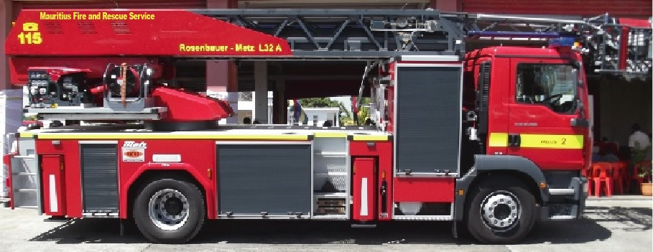

The number of firecalls (fire incidents dealt with by fire crews) attended by the fire stations in 2013 amounted 10,693. In 71% of cases the Fire and Rescue team were deployed to intervene in various type of fire throughout the country. Special services² and Assistance offered to other agencies³ accounted to 28% and 1% respectively (Table 2).

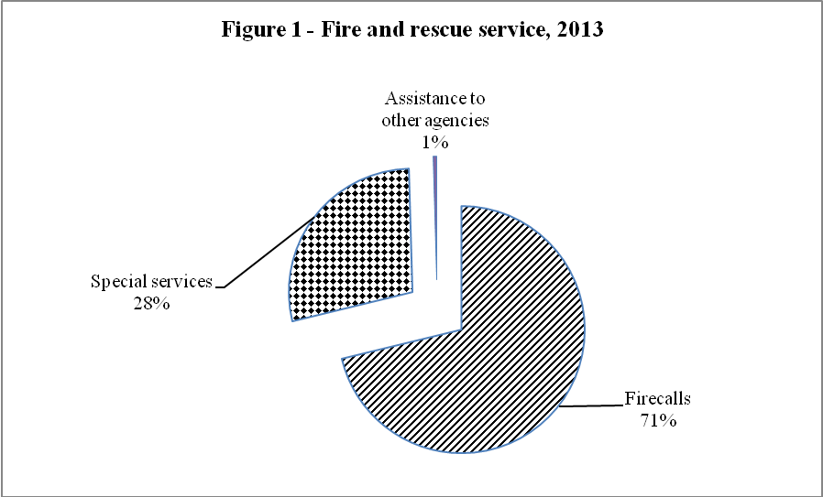

² include pumping of accumulated water, flushing, road accident, rescue operation, supply of water and flooding.

³ Assistance offered to the Police, health institutions and Ministry of Environment.

5. Fire outbreak by Type of Fire

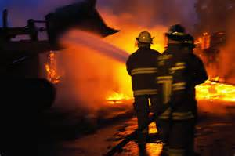

Most (37%) fire incidents occurred in grass lands and sugar cane fields (33%). These fires may be malicious or intentional and requires mobilization of lots of resources to deal with. Residential and non – residential property fires accounted for 8% (Table 4).

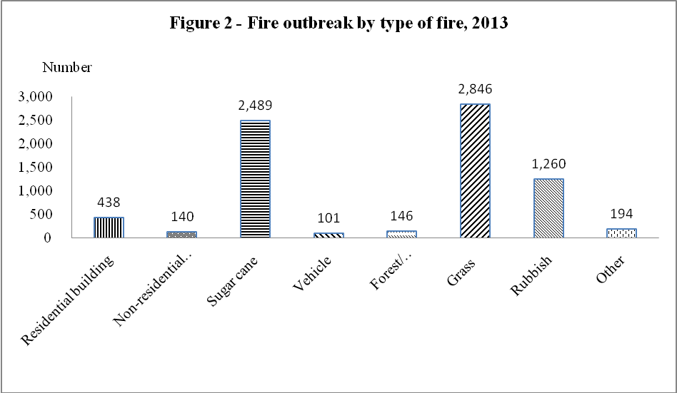

Data Source: Fire Prevention Unit

The Fire Prevention Unit carries out inspection of buildings, filling stations, fuel depots, gas installations, office and commercial buildings, places of public entertainment, and other premises prone to fire hazards throughout the island for the purpose of fire certification and registration. In addition, the Unit conducts fire safety educational programmes for various categories of target groups, including workers, students and citizens.

- Applications received and certificates issued

Fire certificate is issued when more than 10 persons are so employed elsewhere than on the ground floor or where highly flammable material is used or stored.

A fire clearance is issued subject that the building satisfies fire safety norms as required by MFRS.

The number of applications received for fire certificate and fire clearance was 2,598 and the number of fire certificate and fire clearance issued summed up to 869 (33%) (Tables 10 & 11).

- Public education activities

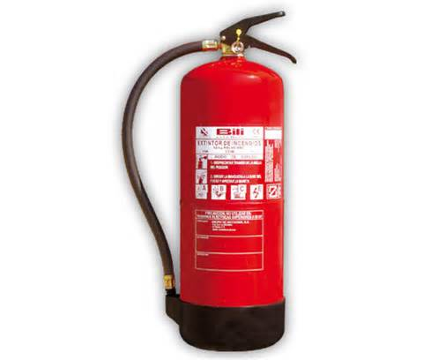

In 2013, the Fire Prevention Section undertook 536 campaigns in connection with fire safety awareness through talks, lectures, demonstrations and broadcast to the population (Table 12).

8. Inquiries

For further information, contact:

Mr. Sewnarain HAULCOOREE, Statistician

Office address: Statistics Mauritius, L.I.C Centre, Port-Louis

Email: shaulcooree@mail.gov.mu; su_fsd@mail.gov.mu
Tel: (230) 210-8885 ext 227 & 239

Statistics Mauritius
Ministry of Finance and Economic Development
Port Louis
May 2014

