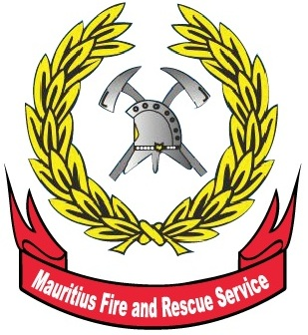

Mauritius

Fire and Rescue Service

Statistical Report 2014

May 2015
TABLE OF CONTENTS

3 | Introduction
8 | Table 1 - Monthly average time taken to reach fire location by station, 2013 - 2014
9 | Table 2 - Number of firecalls, special services and assistance to other agencies by station, 2013 - 2014
10 | Table 3 - Number of firecalls, special services and assistance to other agencies by district, 2013 - 2014
11 | Table 4 - Number of firecalls by station and nature of fire, 2013 - 2014
12 | Table 5 - Number of firecalls by district and nature of fire, 2013 - 2014
13 | Table 6 - Number of assistance offered to other agencies by station, 2013 - 2014
14 | Table 7 - Number of assistance offered to other agencies by district, 2013 - 2014
15 | Table 8 - Number of sugar cane fire (SCF) by station and damage, 2013 - 2014
16 | Table 9 - Number of sugar cane fire (SCF) by district and damage, 2013 - 2014
17 | Table 10 - Number of fire certificate and fire clearance applications received by district, 2013 - 2014
18 | Table 11 - Number of fire certificate and fire clearance issued by district, 2013 - 2014
19 | Table 12 - Number of fire and other emergency safety awareness campaigns undertook by Mauritius Fire and Rescue Service, 2013 - 2014
Mauritius Fire and Rescue Statistics, 2014

- Introduction

The Mauritius Fire and Rescue Service (MFRS), formerly known as the Government Fire Services, was set up in 1954. It is a department falling under the aegis of the Ministry of Local Government and Outer Islands.

The prime mission of MFRS is to protect life and property against destruction by fire in Mauritius. It also tenders advice on fire prevention and protection measures, while giving support in rescue operations during natural disasters and major accidents.

MFRS is a key stakeholder of the National Disaster and Operations Coordination Centre set up by the Government to ensure timely disaster management response.

The MFRS provides special services and assistance to the community in non-emergency situations.

All data in this report relate to the Island of Mauritius.

Detailed tables are given at Annex.

Key indicators

This second issue provides statistics based on administrative data for 2014 collected by the Control and Mobilising Centre and the Fire Safety Division. The report will be available on MFRS website at http://fsd.govmu.org as well as on Statistics Mauritius website at http://statsmauritius.govmu.org
Key indicator |  |  |  |  |  |  |  | Unit |  |  | 22013 2014 % change
Overall average time taken to reach incident spot |  |  |  |  |  |  |  | Mins |  |  | 8 8 -
Fire incident and special assistance attended by Mauritius Fire and Rescue Service |  |  |  |  |  |  |  | Number |  |  | 10,693 11,128 4.1
Fire outbreak attended |  |  |  |  |  |  |  | Number |  |  | 7,614 8,369 9.9
of which: | Structural Fire |  |  |  |  |  |  | Number |  |  | 578 536 -7.3
 | Sugar Cane Fire |  |  |  |  |  |  | Number |  |  | 2,489 2,822 13.4
 | Outside Fire |  |  |  |  |  |  | Number |  |  | 4,446 4,895 10.1
Application for fire certificate and fire clearance |  |  |  |  |  |  |  | Number |  |  | 2,598 2,083 -19.8
Issue of fire certificate and fire clearance |  |  |  |  |  |  |  | Number |  |  | 1,836 1,731 -5.7
% of fire certificate and fire clearance over total application |  |  |  |  |  |  |  |  |  |  | 71 83 -
Public education activities (lectures delivered) |  |  |  |  |  |  |  | Number |  |  | 536 481 -10.3

3. Average time taken to reach incident spot
One of the indicators in the Programme Based Budget (PBB) is the time taken to reach an incident spot most particularly in case of structural fires¹ where human life may be at stake. The set target is 12 minutes. This indicator enables one to gauge the efficiency and the effectiveness of MFRS to promptly respond to an emergency situation. From data obtained with regards to structural fires for the year 2014, it is observed that on average, the fire crew takes approximately 8 minutes to reach the location (Table 1), same as year 2013. Note that the time taken by each fire station varies due to the area coverage and the ease of accessibility.
¹ Any fire inside, on, under or touching a construction for occupancy and use for a specific purpose.

- Fire and rescue service statistics

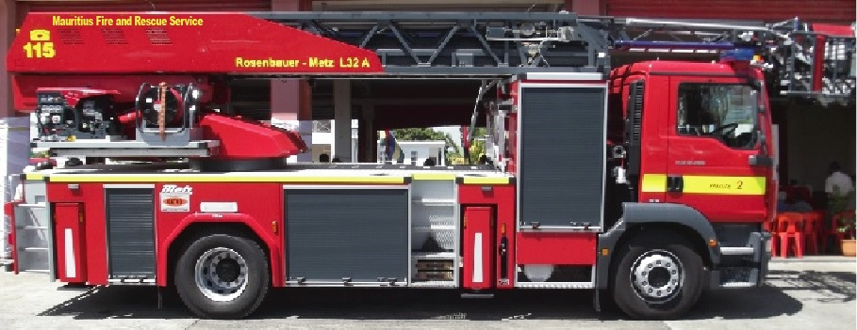

The number of calls in respect of fire incidents, special services and assistance to other agencies attended by the fire stations increased by 435 (4.1%) from 10,693 in 2013 to 11,128 in 2014. The upsurge may be explained by increases in forest/tree fires (+46.6%), rubbish fires (+37.9%) and sugar cane fires (+13.4%) partly offset by decreases in residential property fires (-11.4%) and grass fires (-3.0%). In 2014, the number of firecalls (fire incidents dealt with by fire crews) was 8,369, representing an increase of 755 (9.9%) as compared to 7,614 in 2013. Special services² offered by the Fire and Rescue team decreased by 346 (11.4%) from 3,029 in 2013 to 2,683 in 2014 while the assistance given to other agencies³ increased by 26 (52.0%) from 50 in 2013 to 76 in 2014 (Tables 2 & 4).
In 2014, firecalls accounted for around 75% of the fire and rescue services, special services 24% and assistance to other agencies, 1%.

² Include pumping of accumulated water, flushing, road accident, rescue operation and supply of water.

³ Assistance offered to the Police, Health Institutions and Ministry of Environment.
- Fire outbreak by Type of Fire

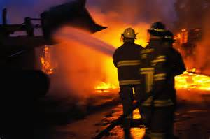

Compared to the year 2013, residential property fires went down by 11.4% from 438 to 388 while non-residential property fires went up by 5.7% from 140 to 148. Fire incidents occurred in sugar cane fields increased by 13.4% from 2,489 in 2013 to 2,822 in 2014. In 2014, 116 vehicles fires were reported, representing an increase of 14.9% over the figure of 101 in 2013. Outside fire, comprising forest/tree, grass, rubbish and other fire outbreak increased by 10.1% from 4,446 in 2013 to 4,895 in 2014 (Table 4).

6. Applications received and certificates issued

Fire certificate is issued when more than 10 persons are so employed elsewhere than on the ground floor or where highly flammable material is used or stored.

A fire clearance is issued subject that the building satisfies fire safety norms as required by MFRS.

The number of applications received for fire certificate in 2014 was 879 against 1,254 in 2013, showing a decrease of 29.9%. In 2014, the number of fire certificate issued was 687, a fall of 21.1% over the figure of 871 in 2013 (Tables 10 & 11).

Compared to 2013, the number of applications received for fire clearance went down by 10.4% from 1,344 to 1,204. The number of fire clearance issued went up by 8.2% from 965 in 2013 to 1,044 in 2014 (Tables 10 & 11).

7. Public education activities

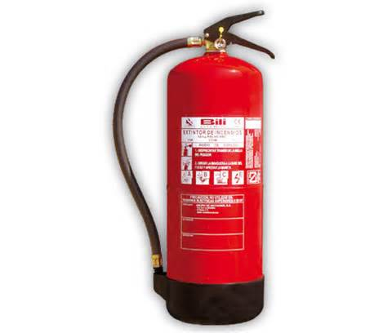

In 2014, the Mauritius Fire and Rescue Service undertook 481 awareness campaigns, representing a decrease of 10.3% over the figure of 536 in 2013. The awareness campaigns were conducted with respect to fire and other emergency safety measures through talks, lectures, demonstrations and broadcast to the population (Table 12).

8. Inquiries

For further information, contact:

Mrs F. Mohamud, Senior Statistical Officer

Mauritius Fire and Rescue Service

14 Descharts street, Port-Louis

Email: fmohamud@govmu.org, su_fsd@govmu.org
Tel: (230) 210-8885 ext 227 & 239

Statistics Mauritius
Ministry of Finance and Economic Development
Port Louis
May 2015

